**FINAL REPORT - DOCSPOT**

**DocSpot: Seamless Appointment Booking for Health**

|  |  |
| --- | --- |
| **Team ID** | LTVIP2026TMIDS35442 |
| **Project Name** | DocSpot: Seamless Appointment Booking for Health |
| **Team Members** | Botla Siva Satyanarayana  Perabathula Satya Sai Manikanta Satya Srithadi Prathi Adithya Durga Sri Krishna Kumar |

**1. INTRODUCTION**

**1.1 Project Overview**

DocSpot is a full-stack web application designed to simplify the process of booking doctor appointments. The platform connects patients with healthcare providers through an intuitive online interface, eliminating the need for traditional phone-based appointment scheduling. Built using the MERN stack (MongoDB, Express.js, React.js, Node.js), DocSpot provides separate dashboards for patients, doctors, and administrators, each with role-specific functionalities.

The system allows patients to browse doctors by specialization, view detailed profiles including qualifications and fees, book appointments by selecting date and time, upload medical documents, and manage their bookings through a personal dashboard. Doctors can register on the platform (pending admin approval), complete their professional profiles, set available timings, and manage appointment requests by approving or rejecting them. Administrators have oversight of the entire platform, including doctor verification, user management, and appointment monitoring.

**1.2 Purpose**

The purpose of DocSpot is to address the following challenges in traditional healthcare appointment booking:

* **For Patients**: Eliminate long phone calls, waiting on hold, and limited clinic hours by providing 24/7 online booking with real-time availability and transparent doctor information.
* **For Doctors**: Reduce administrative burden by digitizing schedule management, minimize no-shows through digital tracking, and increase visibility to potential patients.
* **For Administrators**: Ensure platform integrity through doctor verification, monitor platform activity, and maintain quality control.

**2. IDEATION PHASE**

**2.1 Problem Statement**

**Primary Problem:**  
Patients struggle to book doctor appointments due to phone-only systems, limited clinic hours, no visibility into doctor availability or fees, and no way to track appointments. Doctors waste time on administrative tasks, face high no-show rates, and lack digital tools to manage schedules. Administrators cannot effectively verify doctor credentials or monitor platform activity.

**Customer Problem Statements:**

| **PS #** | **I am (Customer)** | **I'm trying to** | **But** | **Because** | **Which makes me feel** |
| --- | --- | --- | --- | --- | --- |
| PS-1 | A working professional with busy schedule | Book a doctor appointment without taking time off work | I have to call multiple clinics during work hours and wait on hold | Most clinics only accept phone bookings during limited hours | Frustrated and stressed |
| PS-2 | A patient seeking a specialist | Find a qualified doctor with good reviews | I don't know which doctors are available or their consultation fees | There's no centralized platform with doctor information | Confused and uncertain |
| PS-3 | A parent with sick child | Get urgent pediatric appointment | I don't know which clinics have same-day availability | No real-time visibility into doctor slots | Anxious and scared |
| PS-4 | A busy doctor | Manage my appointment schedule efficiently | I receive phone calls at all hours for bookings | My receptionist can't handle the volume | Overwhelmed and stressed |
| PS-5 | A platform administrator | Ensure only verified doctors join | Fake practitioners might try to register | No streamlined verification process | Concerned about platform credibility |

**2.2 Empathy Map Canvas**

**EMPATHY MAP 1: PATIENT USER**

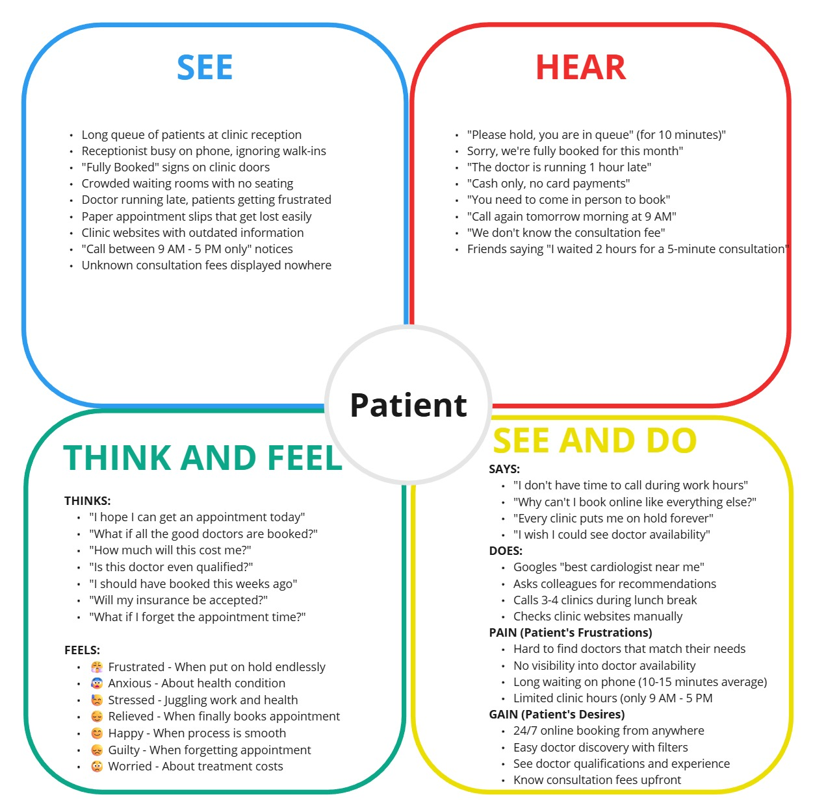

**EMPATHY MAP 2: DOCTOR USER**

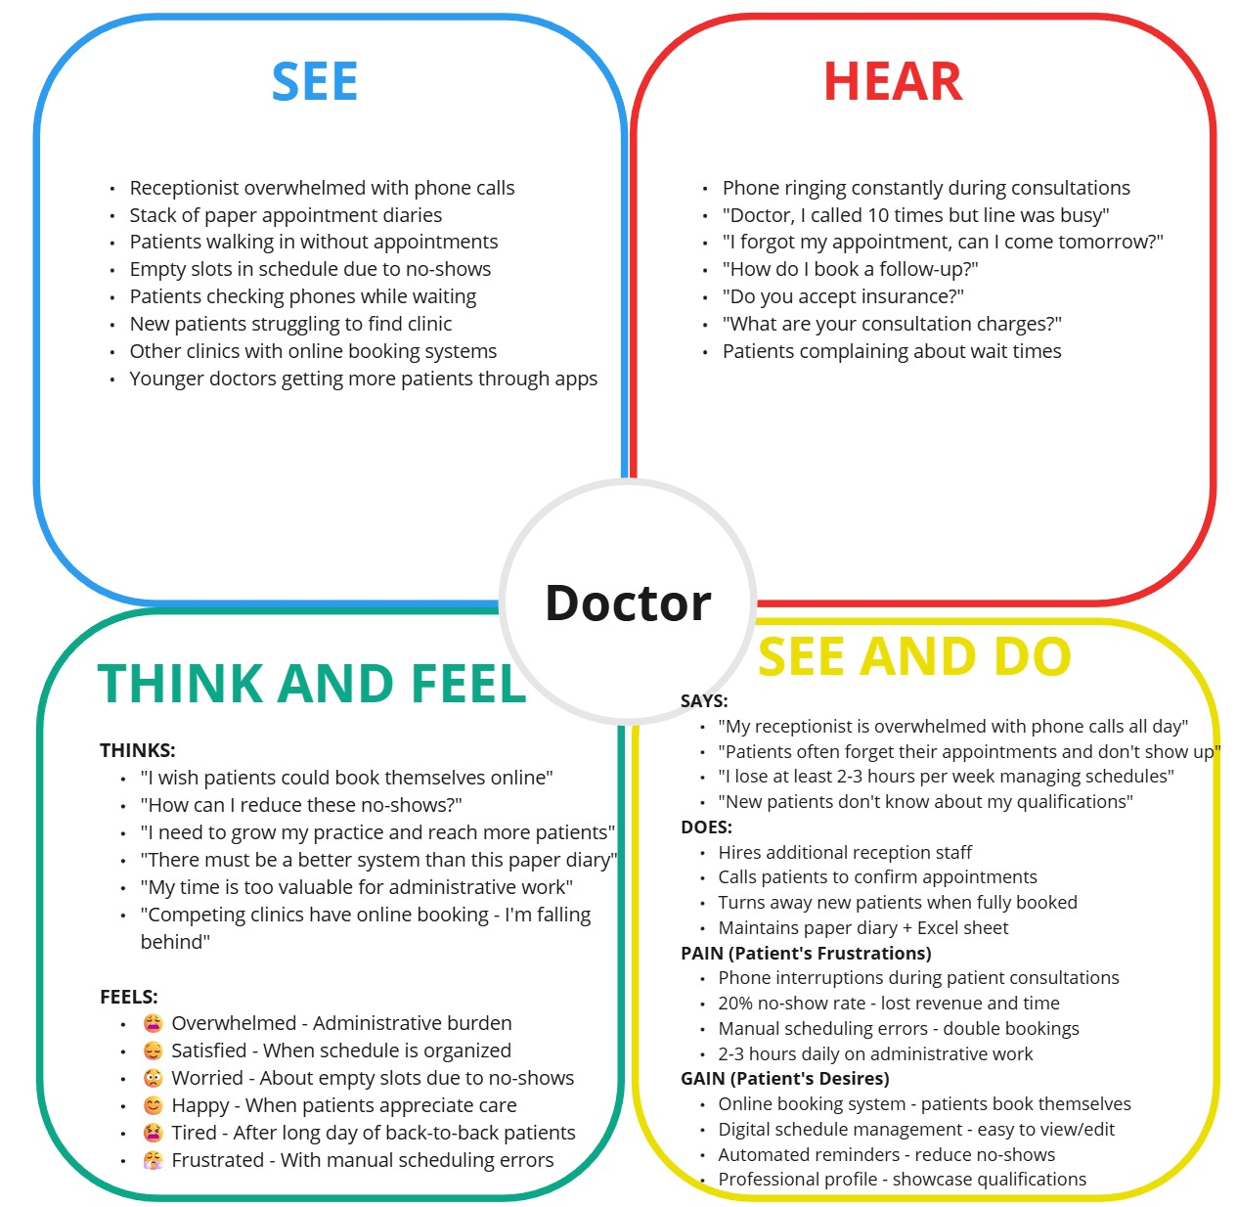

**EMPATHY MAP 3: ADMIN USER**

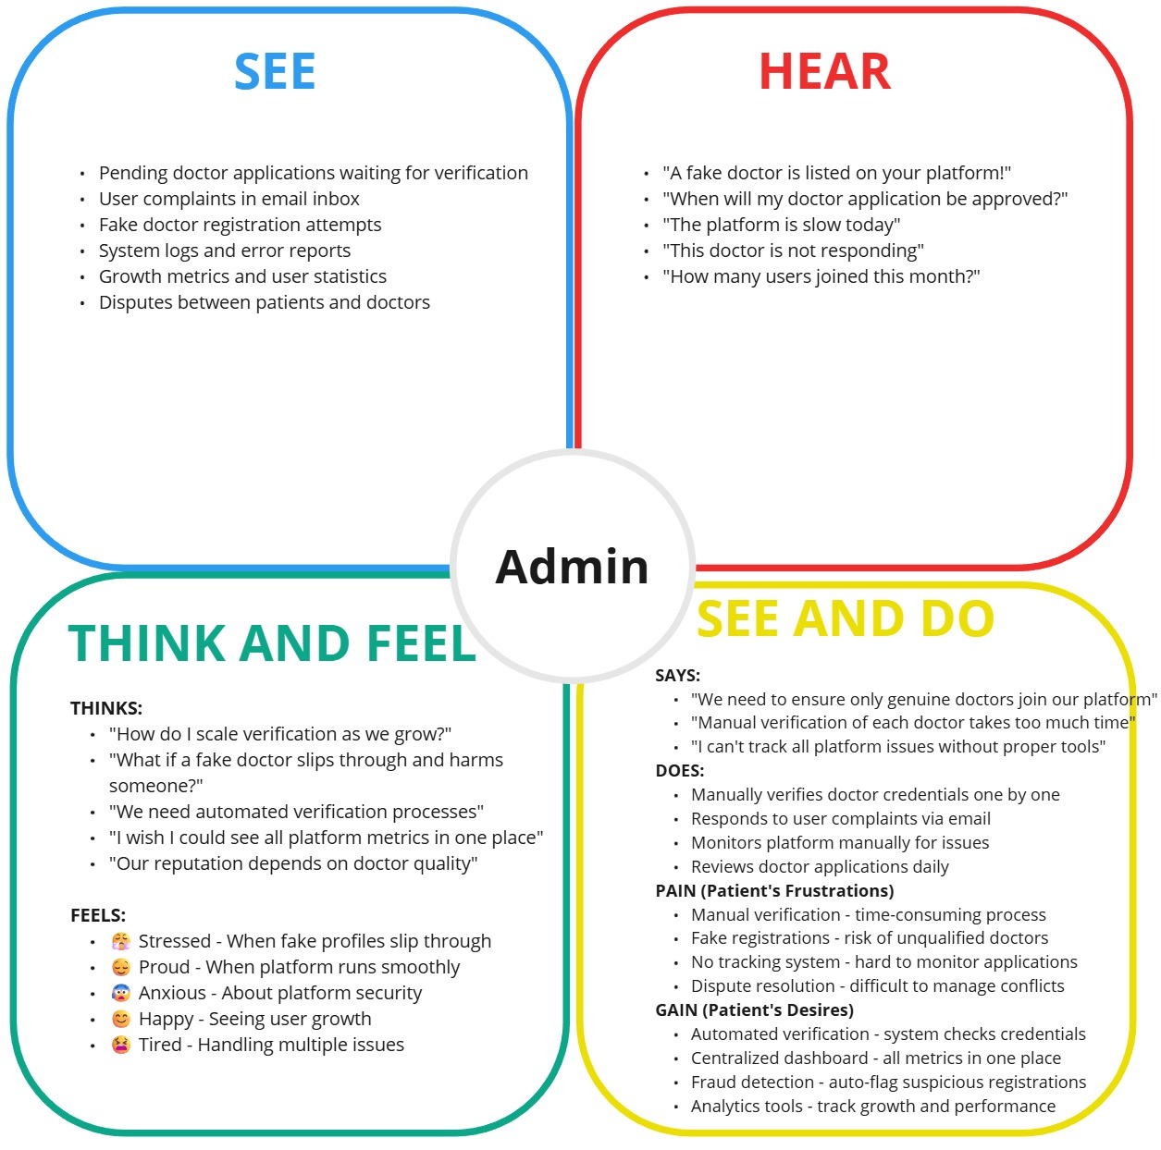

**2.3 Brainstorming**

|  |  |
| --- | --- |
| Date | 16 February 2026 |
| Team ID | LTVIP2026TMIDS35442 |
| Project Name | DocSpot: Seamless Appointment Booking for Health |
| Maximum Marks | 4 Marks |

# **Team Members & Roles**

|  |  |
| --- | --- |
| Name | Role |
| Prathi Adithya Durga Sri Krishna Kumar | Full Stack Developer (MERN) |
| Botla Siva Satyanarayana | Full Stack Developer |
| Perabathula Satya Sai Manikanta | Frontend Developer |
| Satya Srithadi | Backend Developer |

# **Step 1: Team Gathering, Collaboration, and Selecting the Problem Statement**

**Problem Statement:**

To develop a seamless online doctor appointment booking platform called "DocSpot" that allows patients to easily find and book appointments with doctors, enables doctors to efficiently manage their schedules, and provides administrators with tools to oversee the entire healthcare ecosystem - ultimately improving healthcare accessibility and reducing the hassle of traditional appointment booking.

**Motivation:**

Booking a doctor's appointment traditionally involves long phone calls, waiting on hold, playing phone tag with busy receptionists, and limited visibility into doctor availability. Patients struggle to find the right doctor that matches their needs, while doctors face challenges in managing their schedules and reducing no-shows. DocSpot bridges this gap by providing a user-friendly online platform with real-time availability, doctor profiles, appointment management, and administrative oversight - making healthcare booking simple, transparent, and efficient for everyone.

# **Step 2: Brainstorming, Idea Listing, and Grouping**

**Initial Ideas:**

* User registration and login system with email/password
* JWT-based authentication for security
* Browse doctors with filters (specialization, location, fees)
* Real-time doctor availability calendar
* One-click appointment booking
* Upload medical documents during booking
* Email notifications for confirmations and reminders
* Cancel and reschedule appointments
* View booking history in user dashboard
* Doctor registration with approval workflow
* Doctor profile management (qualifications, experience, fees)
* Doctor dashboard to manage appointments
* Approve/reject appointment requests
* Admin dashboard to monitor platform
* Admin approval for new doctor registrations
* User management for admins
* View all appointments across platform
* Responsive design for mobile and desktop
* Notification system for all users
* Secure password encryption with bcrypt
* MongoDB database for scalable data storage
* RESTful APIs for frontend-backend communication
* File upload system for medical documents
* Role-based access control (User/Doctor/Admin)
* Beautiful UI with Bootstrap and custom CSS
* Landing page with platform features
* About and Contact pages
* 404 error page handling
* Loading states and error handling
* Toast notifications for user feedback

**Grouped into Modules:**

| **Module** | **Features Included** |
| --- | --- |
| **1. Authentication Module** | User Registration, Login, JWT Authentication, Password Encryption, Role-based Access |
| **2. Doctor Discovery Module** | Browse Doctors, Search Filters (Specialization, Location, Fees), Doctor Profiles, Availability Calendar |
| **3. Appointment Booking Module** | Book Appointment, Select Date/Time, Upload Documents, Instant Confirmation |
| **4. Appointment Management Module** | View Appointments, Cancel Appointment, Reschedule, Status Tracking (Pending/Approved/Completed) |
| **5. Notification Module** | Email Notifications, In-App Alerts, Appointment Reminders, Status Updates |
| **6. Doctor Dashboard Module** | Manage Schedule, View Requests, Approve/Reject Appointments, Profile Editing |
| **7. Admin Dashboard Module** | User Management, Doctor Approval, Platform Monitoring, View All Appointments |
| **8. UI/UX Module** | Responsive Design, Landing Page, Navigation Bar, Footer, Loading States, Error Handling |
| **9. Profile Management Module** | User Profile, Edit Details, View History, Notification Center |
| **10. Database Module** | MongoDB Schemas (Users, Doctors, Appointments), Data Relationships, Indexes |

# **Step 3: Idea Prioritization (Final Version)**

| **Feature / Module** | **Importance** | **Feasibility** | **Notes** |
| --- | --- | --- | --- |
| **Authentication Module** | High | High | User registration and login with JWT – core requirement |
| **Doctor Discovery Module** | High | High | Browse and filter doctors – essential for user experience |
| **Appointment Booking Module** | High | High | Book appointments with date/time – primary functionality |
| **Appointment Management Module** | High | High | View, cancel, reschedule – user control |
| **Notification Module** | High | Medium | Email confirmations and reminders – improves engagement |
| **Doctor Dashboard Module** | High | High | Doctors manage their appointments – critical for workflow |
| **Admin Dashboard Module** | High | High | Platform oversight and doctor approval – ensures trust |
| **Profile Management Module** | Medium | High | User profile and history – enhances personalization |
| **UI/UX Module** | High | High | Responsive, clean interface – key to user adoption |
| **Database Module** | High | High | MongoDB with proper schemas – foundation of the system |

**3. REQUIREMENT ANALYSIS**

**3.1 Customer Journey Map**

**PATIENT JOURNEY MAP**

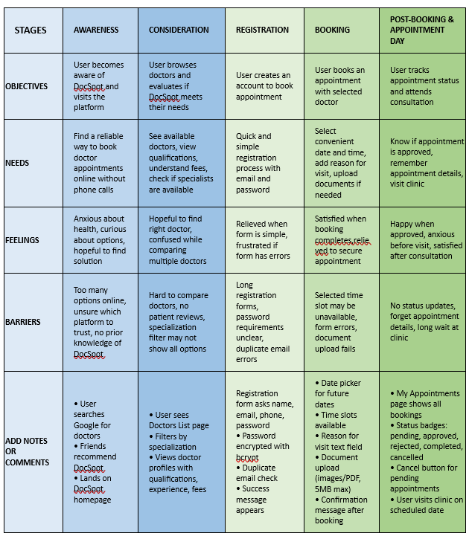

**DOCTOR JOURNEY MAP**

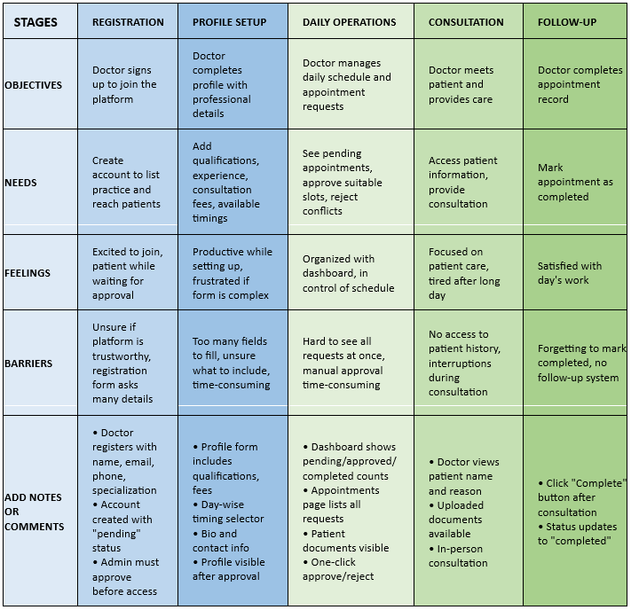

**ADMIN JOURNEY MAP**

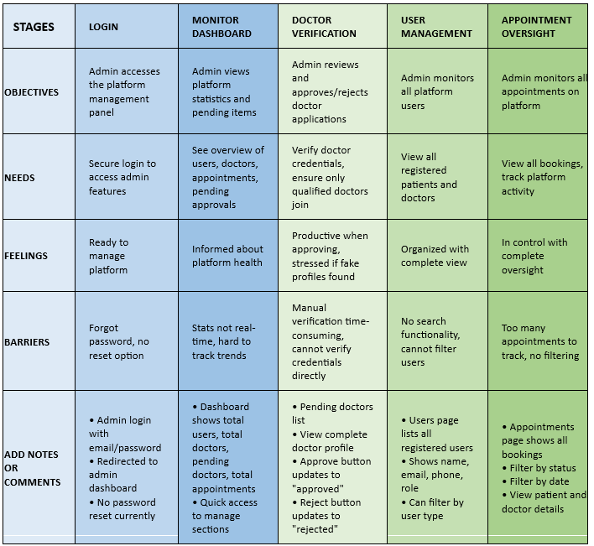

**3.2 Solution Requirements (Functional & Non-functional)**

|  |  |
| --- | --- |
| Date | 16 February 2026 |
| Team ID | LTVIP2026TMIDS35442 |
| Project Name | DocSpot: Seamless Appointment Booking for Health |
| Maximum Marks | 4 Marks |

**Functional Requirements:**

Following are the functional requirements of the proposed solution.

| **FR No.** | **Functional Requirement (Epic)** | **Sub Requirement (Story / Sub-Task)** |
| --- | --- | --- |
| FR-1 | User Registration | * 1. Registration through email and password   2. Password encryption using bcrypt   3. Phone number validation   4. Duplicate email check |
| FR-2 | User Login | 2.1 Login with email and password  2.2 JWT token generation  2.3 Token storage in localStorage  2.4 Session management |
| FR-3 | Role-Based Access Control | 3.1 Patient role with limited access  3.2 Doctor role with appointment management  3.3 Admin role with platform oversight  3.4 Protected routes based on role |
| FR-4 | Doctor Discovery | 4.1 List all approved doctors  4.2 Filter by specialization  4.3 View doctor profiles (qualifications, experience, fees)  4.4 Doctor cards with basic info |
| FR-5 | Appointment Booking | 5.1 Select appointment date  5.2 Select time slot  5.3 Upload medical documents  5.4 Add reason for visit  5.5 Submit booking request  5.6 Display confirmation message |
| FR-7 | Appointment Management (Doctor) | 7.1 View all appointment requests  7.2 Approve pending appointments  7.3 Reject appointments with reason  7.4 Mark appointments as completed |
| FR-8 | Doctor Profile Management | 8.1 Add/update qualifications  8.2 Set consultation fees  8.3 Configure available timings (day-wise)  8.4 Add bio/description  8.5 Update contact information |
| FR-9 | Admin Doctor Approval | 9.1 View pending doctor applications  9.2 Review doctor details  9.3 Approve qualified doctors  9.4 Reject unqualified doctors |
| FR-10 | Admin User Management | 10.1 View all registered users  10.2 Filter users by type (patient/doctor)  10.3 View user details |
| FR-11 | Admin Appointment Oversight | 11.1 View all appointments  11.2 Filter by status  11.3 Filter by date |
| FR-12 | Dashboard | 12.1 Patient dashboard with upcoming appointments  12.2 Doctor dashboard with stats (pending/approved/completed)  12.3 Admin dashboard with platform metrics |
| FR-13 | File Upload | 13.1 Upload medical documents (images/PDF)  13.2 Multiple file upload support  13.3 File size limit (5MB)  13.4 View uploaded files in appointment details |
| FR-14 | Logout | 14.1 Secure logout clearing session  14.2 Redirect to home page |

**Non-functional Requirements:**

Following are the non-functional requirements of the proposed solution.

|  |  |  |
| --- | --- | --- |
| **FR No.** | **Non-Functional Requirement** | **Description** |
| NFR-1 | **Usability** | * Intuitive UI with clear navigation * Responsive design works on mobile, tablet, desktop * Consistent color scheme (blue/white professional theme) * Loading states for async operations * Error messages with user-friendly language * Form validation with clear feedback * Maximum 3 clicks to book appointment |
| NFR-2 | **Security** | * Passwords hashed using bcrypt before storage * JWT tokens for authentication * Protected routes prevent unauthorized access * Role-based access control (patient/doctor/admin) * Environment variables for sensitive data * Input validation and sanitization * MongoDB injection prevention * File upload type restrictions (only images/PDFs) * File size limit (5MB) |
| NFR-3 | **Reliability** | * Graceful error handling with user feedback * Data persistence in MongoDB Atlas * Automatic reconnection on database failure * Consistent appointment status tracking |
| NFR-4 | **Performance** | * Page load time < 3 seconds * API response time < 500ms * Doctor list loads within 2 seconds * Supports 100+ concurrent users * Database indexing for faster queries * Optimized images and assets * Efficient MongoDB queries |
| NFR-5 | **Availability** | * Hosted on localhost during development * MongoDB Atlas cloud database (99.9% uptime) * Application available 24/7 * Quick recovery from crashes * Graceful degradation on service failure |
| NFR-6 | **Scalability** | * MongoDB Atlas can scale with data growth * Stateless JWT authentication allows horizontal scaling * Modular architecture (separate frontend/backend) * Indexed collections for fast queries * Can add more server instances * React components reusable for future features |

**3.3 Data Flow Diagram**

|  |  |
| --- | --- |
| Date | 16 February 2026 |
| Team ID | LTVIP2026TMIDS35442 |
| Project Name | DocSpot: Seamless Appointment Booking for Health |
| Maximum Marks | 4 Marks |

**Data Flow Diagrams:**

A Data Flow Diagram (DFD) is a traditional visual representation of the information flows within a system. A neat and clear DFD can depict the right amount of the system requirement graphically. It shows how data enters and leaves the system, what changes the information, and where data is stored.

**External Entities:**

1. Patient - Books and manages appointments
2. Doctor - Manages schedule and appointments
3. Admin - Verifies doctors and monitors platform

**DFD Level 0 (Industry Standard)**

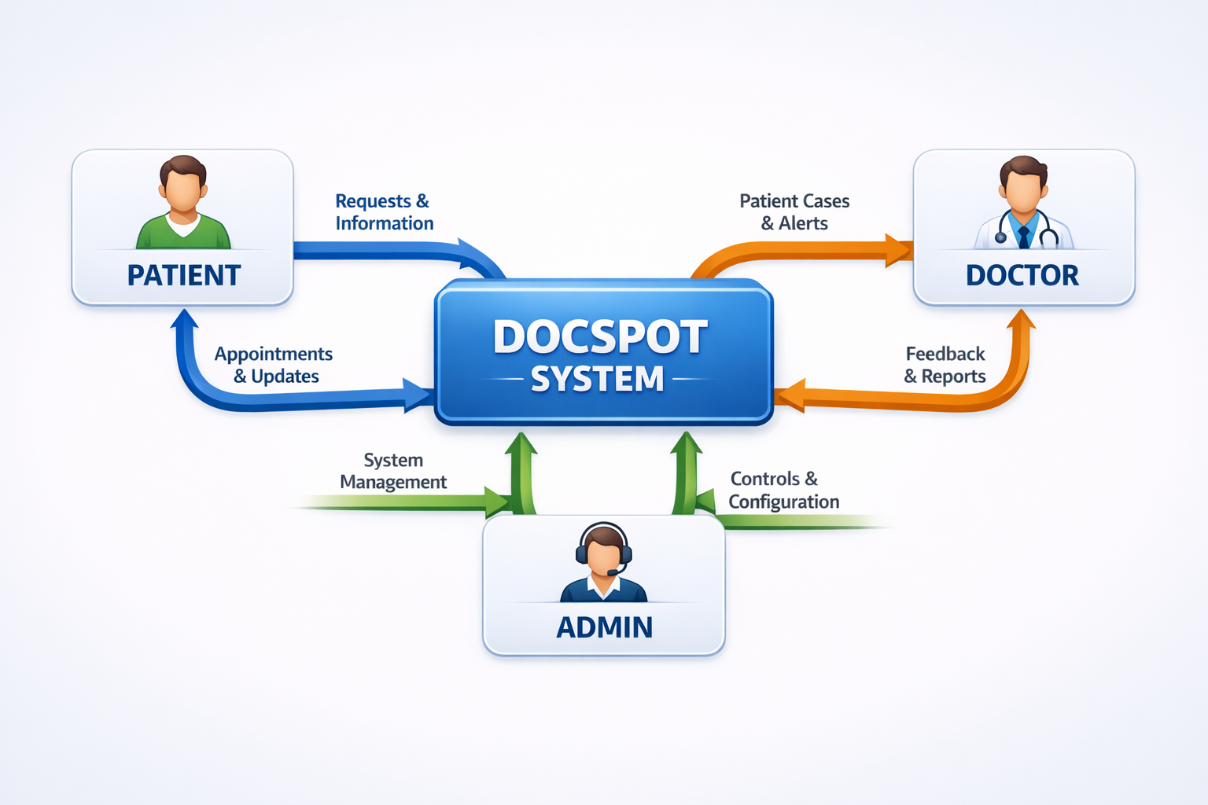

**Level 1 DFD - Patient Processes**

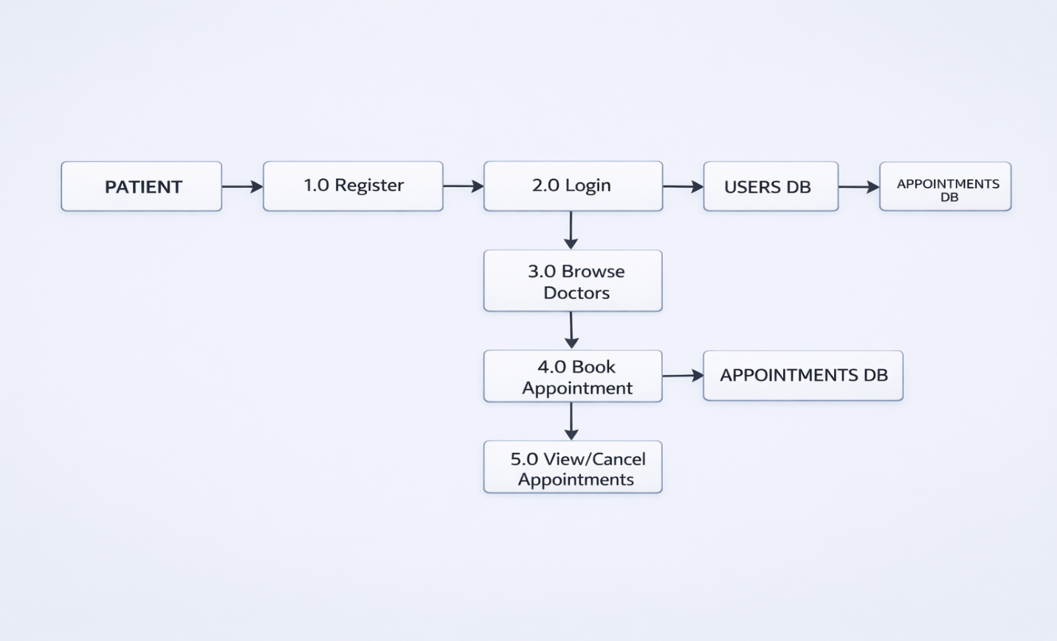

**Processes:**

1. 1.0 Register - Patient creates account with email/password
2. 2.0 Login - Patient authenticates using credentials
3. 3.0 Browse Doctors - Search and filter doctors by specialization
4. 4.0 Book Appointment - Select date/time and book
5. 5.0 View/Cancel Appointments - Manage existing bookings

**Level 1 DFD - Doctor Processes**

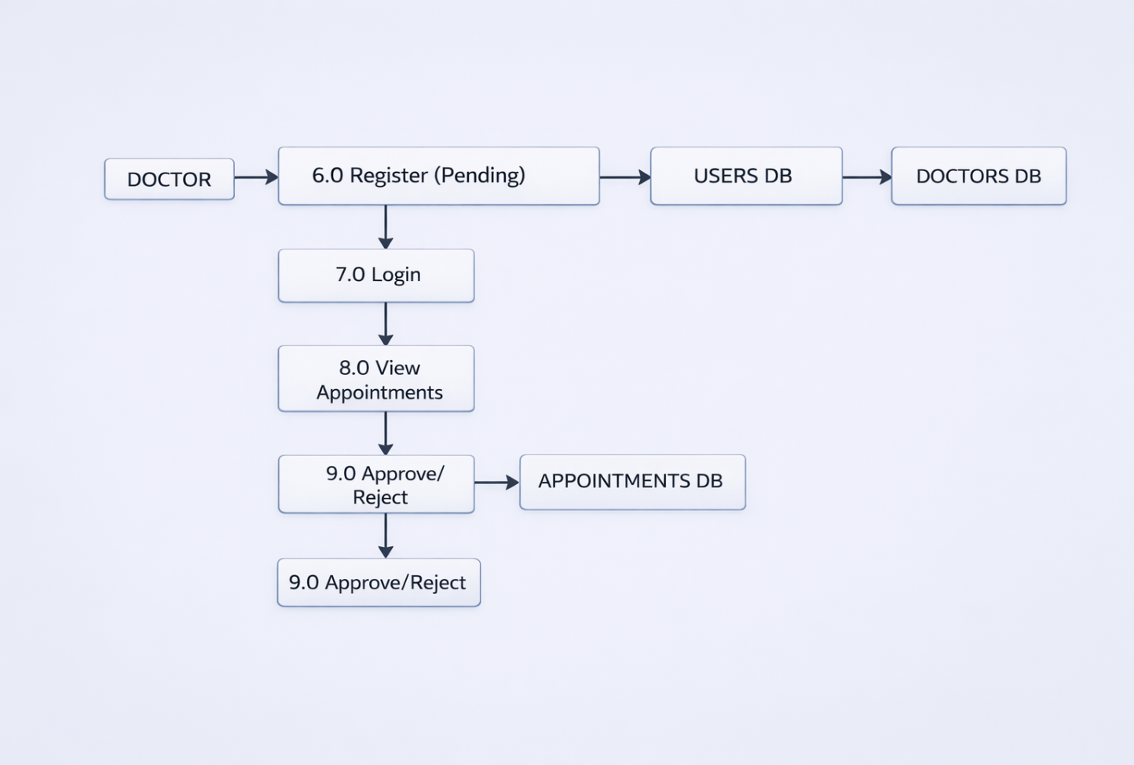

**Processes:**

1. 6.0 Register (Pending) - Doctor applies with pending status
2. 7.0 Login - Doctor authenticates
3. 8.0 View Appointments - See all appointment requests
4. 9.0 Approve/Reject - Update appointment status

**Level 1 DFD - Admin Processes**

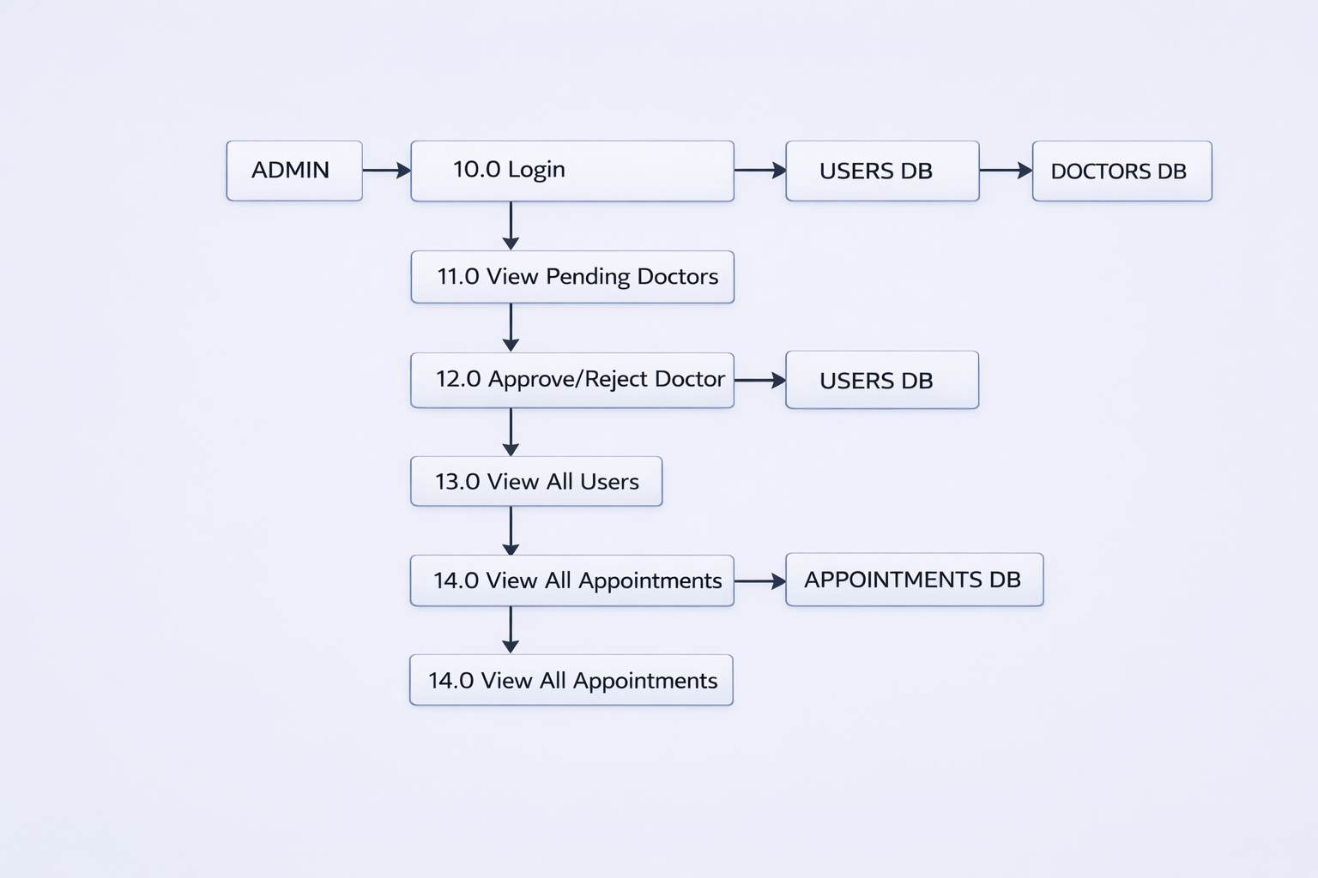

**Processes:**

1. 10.0 Login - Admin authenticates
2. 11.0 View Pending Doctors - See doctor applications

12. 12.0 Approve/Reject Doctor - Update doctor status  
13. 13.0 View All Users - Monitor platform users  
14. 14.0 View All Appointments - Overview of all bookings

**User Stories**

Use the below template to list all the user stories for the product.

| **User Type** | **Functional Requirement (Epic)** | **User Story Number** | **User Story / Task** | **Acceptance Criteria** | **Priority** | **Release** |
| --- | --- | --- | --- | --- | --- | --- |
| **Patient** | Registration | US-P-01 | As a patient, I can register using my email, password, and phone number | I can access my dashboard after registration | High | Sprint-1 |
|  | Login | US-P-02 | As a patient, I can log in using my email and password | I am redirected to my dashboard | High | Sprint-1 |
|  | Browse Doctors | US-P-03 | As a patient, I can view all approved doctors with their specializations | List of doctors displays with names | High | Sprint-1 |
|  |  | US-P-04 | As a patient, I can filter doctors by specialization | Only doctors of selected specialty are shown | High | Sprint-1 |
|  |  | US-P-05 | As a patient, I can view doctor details including fees and experience | Doctor profile shows complete information | High | Sprint-1 |
|  | Book Appointment | US-P-06 | As a patient, I can select a date and time to book an appointment | Date picker and time slots are available | High | Sprint-1 |
|  |  | US-P-07 | As a patient, I can upload medical documents while booking | Files can be uploaded and attached to appointment | Medium | Sprint-1 |
|  |  | US-P-08 | As a patient, I receive confirmation after booking | Success message with appointment details appears | High | Sprint-1 |
|  | Manage Appointments | US-P-09 | As a patient, I can view all my appointments in history | My Appointments page shows all bookings | High | Sprint-1 |
|  |  | US-P-10 | As a patient, I can see appointment status (pending/approved/rejected) | Status badges clearly indicate current state | High | Sprint-1 |
|  |  | US-P-11 | As a patient, I can cancel my pending appointment | Appointment status changes to "cancelled" | High | Sprint-1 |
|  | Profile | US-P-12 | As a patient, I can update my profile information | Changes are saved successfully | Medium | Sprint-1 |
|  | Logout | US-P-13 | As a patient, I can securely logout | Session ends and I am redirected to home | High | Sprint-1 |
| **Doctor** | Registration | US-D-01 | As a doctor, I can register with my details (name, email, phone, specialization) | Account is created with "pending" status | High | Sprint-1 |
|  | Login | US-D-02 | As a doctor, I can log in using my email and password | I am redirected to doctor dashboard | High | Sprint-1 |
|  | Profile Management | US-D-03 | As a doctor, I can complete my profile with qualifications and experience | Profile information is saved | High | Sprint-1 |
|  |  | US-D-04 | As a doctor, I can set my consultation fees | Fees are displayed in my profile | High | Sprint-1 |
|  |  | US-D-05 | As a doctor, I can set my available timings for each day of week | Timings are saved and displayed | High | Sprint-1 |
|  | Appointment Management | US-D-06 | As a doctor, I can view all appointment requests | List of appointments with patient details is shown | High | Sprint-1 |
|  |  | US-D-07 | As a doctor, I can approve pending appointments | Status updates to "approved" and patient is notified | High | Sprint-1 |
|  |  | US-D-08 | As a doctor, I can reject appointments I cannot accommodate | Status updates to "rejected" | High | Sprint-1 |
|  |  | US-D-09 | As a doctor, I can mark completed appointments | Status updates to "completed" | Medium | Sprint-1 |
|  | Dashboard | US-D-10 | As a doctor, I can see counts of pending/approved/completed appointments | Dashboard shows statistics | Medium | Sprint-1 |
|  | Logout | US-D-11 | As a doctor, I can securely logout | Session ends and I am redirected to home | High | Sprint-1 |
| **Admin** | Login | US-A-01 | As an admin, I can log in with my credentials | I am redirected to admin dashboard | High | Sprint-1 |
|  | Doctor Management | US-A-02 | As an admin, I can view all pending doctor applications | List of pending doctors is displayed | High | Sprint-1 |
|  |  | US-A-03 | As an admin, I can view complete doctor details for verification | Doctor profile with all information is shown | High | Sprint-1 |
|  |  | US-A-04 | As an admin, I can approve qualified doctors | Doctor status updates to "approved" | High | Sprint-1 |
|  |  | US-A-05 | As an admin, I can reject unqualified doctors | Doctor status updates to "rejected" | High | Sprint-1 |
|  | User Management | US-A-06 | As an admin, I can view all registered users | List of patients and doctors is displayed | Medium | Sprint-1 |
|  | Appointment Oversight | US-A-07 | As an admin, I can view all appointments on the platform | Complete appointment list is displayed | Medium | Sprint-1 |
|  |  | US-A-08 | As an admin, I can filter appointments by status | Filtered results are shown | Medium | Sprint-1 |
|  | Dashboard | US-A-09 | As an admin, I can see platform statistics (total users, doctors, appointments) | Dashboard shows key metrics | High | Sprint-1 |
|  |  | US-A-10 | As an admin, I can see pending approvals count | Dashboard shows pending doctors count | High | Sprint-1 |
|  | Logout | US-A-11 | As an admin, I can securely logout | Session ends and I am redirected to home | High | Sprint-1 |

**3.4 Technology Stack**

|  |  |
| --- | --- |
| Date | 16 February 2026 |
| Team ID | LTVIP2026TMIDS35442 |
| Project Name | DocSpot: Seamless Appointment Booking for Health |
| Maximum Marks | 4 Marks |

**Technical Architecture:**

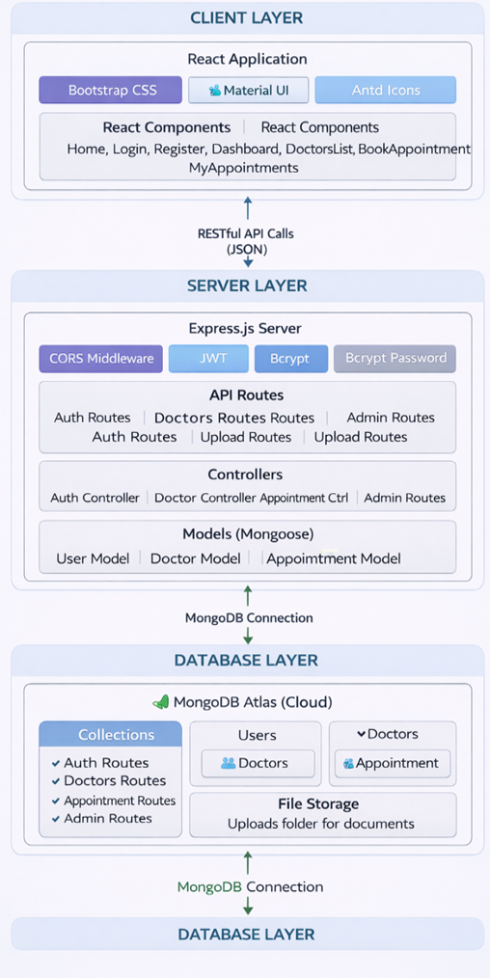

**Data Flow:**

1. User interacts with React frontend
2. Axios sends HTTP requests to Express backend
3. Express routes handle requests via controllers
4. Controllers interact with MongoDB via Mongoose models
5. JWT middleware protects authenticated routes
6. Multer handles file uploads to uploads folder
7. Responses sent back to frontend

**Table-1 : Components & Technologies:**

| **S.No** | **Component** | **Description** | **Technology** |
| --- | --- | --- | --- |
| 1. | User Interface | Web application interface for patients, doctors, and admin | React.js 18.2.0 |
| 2. | UI Component Libraries | Styling and UI components for better user experience | Bootstrap 5.3, React-Bootstrap 2.10, MDB React UI Kit 8.0 |
| 3. | HTTP Client | Communication between frontend and backend | Axios 1.6 |
| 4. | Application Logic - Backend | Server-side logic, API endpoints, business logic | Node.js 22.18, Express.js 4.18 |
| 5. | Authentication | User authentication and authorization | JWT (jsonwebtoken 9.0), Bcryptjs 2.4 |
| 6. | Database | Primary data storage | MongoDB 7.5 (Mongoose ODM) |
| 7. | Cloud Database | Hosted database service | MongoDB Atlas |
| 8. | File Storage | Storage for uploaded medical documents | Local filesystem (uploads folder) with Multer 1.4 |
| 9. | Password Encryption | Secure password hashing | Bcryptjs 2.4 |
| 10. | Environment Configuration | Manage environment variables | Dotenv 16.3 |
| 11. | CORS | Cross-origin resource sharing | CORS 2.8 |
| 12. | Development Tools | Hot reloading for development | Nodemon 3.0 |
| 13. | Date/Time Handling | Parse and format dates | Moment.js |
| 14. | Icons | Icon library for UI | React Icons |
| 15. | Infrastructure (Server) | Application deployment | Localhost (Development) |

**Table-2: Application Characteristics:**

| **S.No** | **Characteristics** | **Description** | **Technology** |
| --- | --- | --- | --- |
| 1. | Open-Source Frameworks | All frameworks used are open-source | React.js, Node.js, Express.js, MongoDB, Bootstrap, JWT, Bcrypt |
| 2. | Security Implementations | • Password hashing with bcrypt • JWT tokens for authentication • Protected routes with middleware • Role-based access control (Patient/Doctor/Admin) • Environment variables for secrets • Input validation and sanitization • CORS configuration • File upload type restrictions | Bcryptjs 2.4, JWT, Express Middleware, CORS, Multer |
| 3. | Scalable Architecture | • Client-server architecture with separation of concerns • Stateless JWT authentication allows horizontal scaling • Modular code structure (controllers, models, routes) • MongoDB Atlas can scale with data growth • Indexed database collections for performance • React components reusable and modular | MERN Stack (MongoDB, Express, React, Node.js) |
| 4. | Availability | • MongoDB Atlas provides 99.9% uptime • Application available 24/7 on localhost • Graceful error handling prevents crashes • Database connection retry on failure | MongoDB Atlas, Express error handling |
| 5. | Performance | • Database indexing for faster queries • JWT tokens reduce database lookups • Efficient MongoDB queries with Mongoose • React virtual DOM for fast rendering • API response time < 500ms | MongoDB indexes, JWT, React virtual DOM |

**References:**

* [**https://reactjs.org/**](https://reactjs.org/)
* [**https://nodejs.org/**](https://nodejs.org/)
* [**https://expressjs.com/**](https://expressjs.com/)
* [**https://www.mongodb.com/atlas**](https://www.mongodb.com/atlas)
* [**https://mongoosejs.com/**](https://mongoosejs.com/)
* [**https://jwt.io/**](https://jwt.io/)
* [**https://github.com/axios/axios**](https://github.com/axios/axios)
* [**https://react-bootstrap.github.io/**](https://react-bootstrap.github.io/)
* [**https://mui.com/**](https://mui.com/)
* [**https://ant.design/**](https://ant.design/)

**4. PROJECT DESIGN**

**4.1 Problem Solution Fit**

|  |  |
| --- | --- |
| Date | 16 February 2026 |
| Team ID | LTVIP2026TMIDS35442 |
| Project Name | DocSpot: Seamless Appointment Booking for Health |
| Maximum Marks | 2 Marks |

**Problem – Solution Fit:**

The Problem-Solution Fit simply means that we have identified real problems faced by patients, doctors, and admins in the healthcare appointment booking ecosystem, and the DocSpot platform we have built actually solves these problems effectively. It helps our team identify behavioral patterns of all three user types and recognize what solutions work and why.

**Purpose:**

❑ Solve complex problems in healthcare appointment booking by providing a digital platform that fits how patients, doctors, and admins naturally work.

❑ Succeed faster by using existing behaviors—patients already search online, doctors already manage schedules, admins already verify—and simply making these processes digital and efficient.

❑ Sharpen communication with the right messaging: "Book doctors 24/7", "No more phone calls", "Manage appointments digitally", "Verified doctors only".

❑ Increase trust by solving frequent annoyances—long phone calls, no-show appointments, fake doctor listings—and building a reliable platform for healthcare access.

❑ Improve the existing situation where patients struggle to book, doctors waste time on admin, and admins lack oversight—by providing a seamless, transparent, and efficient system for everyone.

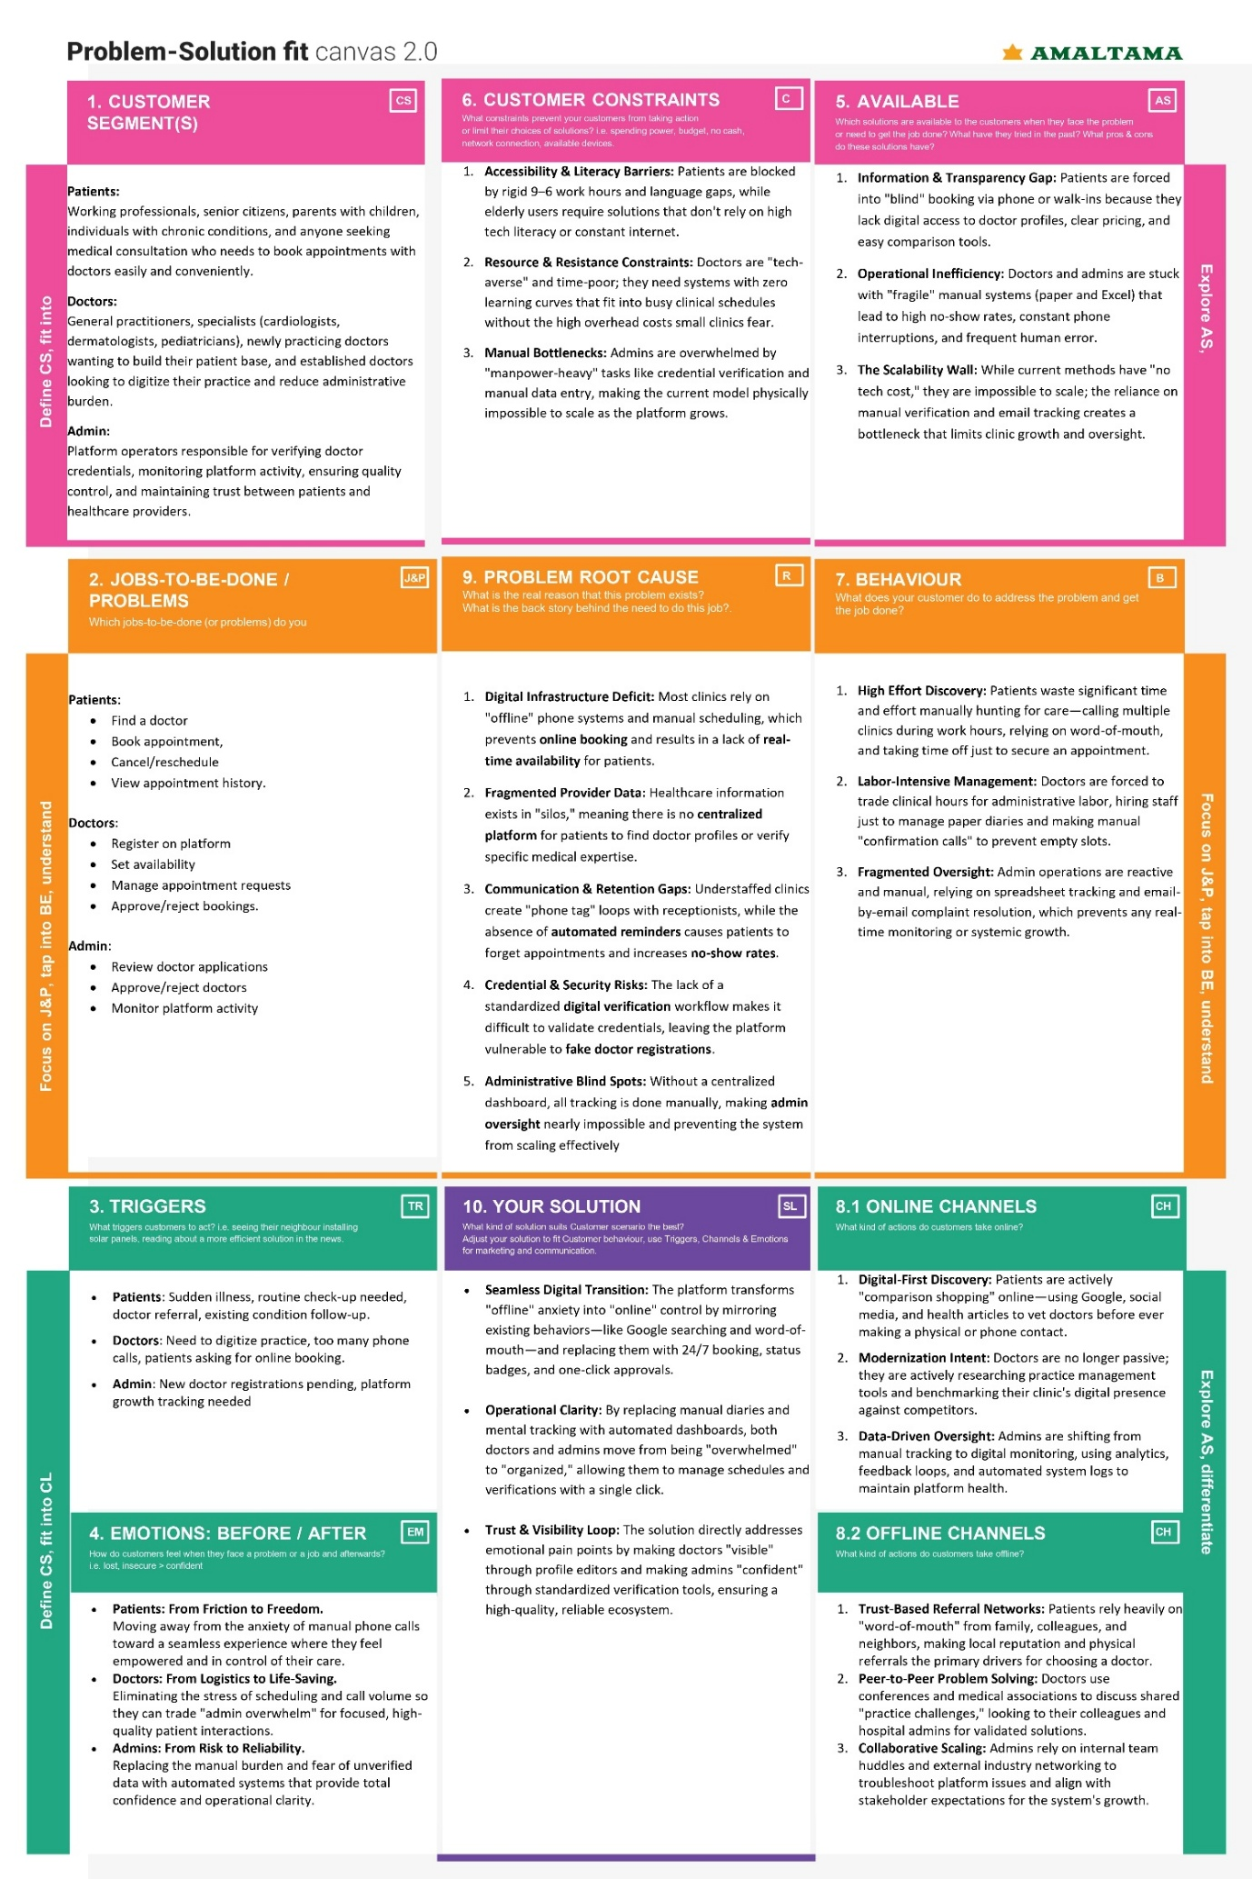

**4.2 Proposed Solution**

|  |  |
| --- | --- |
| Date | 16 February 2026 |
| Team ID | LTVIP2026TMIDS35442 |
| Project Name | DocSpot: Seamless Appointment Booking for Health |
| Maximum Marks | 2 Marks |

**Proposed Solution:**

|  |  |  |
| --- | --- | --- |
| **S.No.** | **Parameter** | **Description** |
|  | Problem Statement (Problem to be solved) | Patients struggle to book doctor appointments due to phone-only systems, limited clinic hours, no visibility into doctor availability or fees, and no way to track appointments. Doctors waste time on administrative tasks, face high no-show rates, and lack digital tools to manage schedules. Admins cannot effectively verify doctor credentials or monitor platform activity. |
|  | Idea / Solution description | DocSpot is a web-based doctor appointment booking platform with three user roles:  **Patients** can register, browse doctors by specialization, view profiles with qualifications and fees, book appointments by selecting date/time, upload medical documents, and manage bookings with status tracking.  **Doctors** can register (pending admin approval), complete profiles with qualifications and timings, and approve/reject appointment requests.  **Admins** can verify and approve/reject doctor applications, view all users, and monitor all appointments. Built using MERN stack (MongoDB, Express, React, Node.js) with JWT authentication. |
|  | Novelty / Uniqueness | • Complete role-based system with separate dashboards for patients, doctors, and admins • Doctor approval workflow ensuring only verified doctors join the platform • Document upload for medical records during booking • Real-time status tracking with pending/approved/rejected/completed/cancelled badges • Filter by specialization for easy doctor discovery • Day-wise timing configuration for doctors • JWT-based secure authentication with role-based access control |
|  | Social Impact / Customer Satisfaction | • **Doctors:** Reduce administrative burden by 50%; eliminate no-shows with digital tracking; focus more on patient care; reach new patients through online presence  • **Community:** Improves healthcare accessibility by digitizing appointment booking; reduces stress for patients seeking medical care; creates trust through verified doctor system |
|  | Business Model (Revenue Model) | • **Free for patients** - Always free to use • **Free for doctors** - Currently free during pilot phase • **Future revenue streams** (not implemented yet): Subscription model for doctors (monthly/yearly), Featured/priority listings for doctors, Commission per booking (optional) |
|  | Scalability of the Solution | • **Technical scalability**: MongoDB Atlas can scale with data growth; stateless JWT authentication allows horizontal scaling; modular MERN architecture supports adding more server instances; indexed collections ensure fast queries even with millions of records • **Geographic scalability**: Can add more cities and regions easily; specialization filters can be expanded • **Feature scalability**: New features can be added as separate modules without disrupting existing functionality • **User scalability**: Currently supports 100+ concurrent users; can scale to thousands with cloud infrastructure |

**4.3 Solution Architecture**

|  |  |
| --- | --- |
| Date | 16 February 2026 |
| Team ID | LTVIP2026TMIDS35442 |
| Project Name | DocSpot: Seamless Appointment Booking for Health |
| Maximum Marks | 4 Marks |

**Solution Architecture:**

DocSpot follows a three-tier client-server architecture with clear separation between presentation, application, and data layers.

**Architecture Overview**

| **Layer** | **Component** | **Description** |
| --- | --- | --- |
| Frontend | React.js | User interface for Patients, Doctors, and Admin. Communicates with backend via RESTful APIs using Axios. |
| Backend | Express.js | Handles business logic, authentication, request processing, and API routing with JWT-based security. |
| Database | MongoDB Atlas | Cloud NoSQL database storing users, doctor profiles, and appointments using Mongoose ODM. |

**Key Components**

**Frontend (React.js)**

* **Components:** Modular UI for each user role (patient, doctor, admin)
* **React Router:** Client-side routing with protected routes based on user roles
* **Axios:** HTTP client for API communication with token attachment
* **Context API:** Global state management for authentication
* **Bootstrap:** Responsive UI components

**Backend (Express.js)**

* **Middleware:** CORS, JSON parsing, JWT authentication, Multer for file uploads
* **Routes:** API endpoints for auth, doctors, appointments, admin
* **Controllers:** Business logic for each entity
* **Models:** Mongoose schemas for Users, Doctors, Appointments
* **JWT:** Token-based authentication with role-based access control

**Database (MongoDB Atlas)**

* **Users Collection:** Stores user credentials, roles, notifications
* **Doctors Collection:** Stores doctor profiles, qualifications, fees, timings
* **Appointments Collection:** Stores booking details, status, document references
* **Indexes:** Optimized queries on email, specialization, status, dates

**Authentication Flow**

1. User registers → Password hashed with bcrypt
2. User logs in → JWT token generated
3. Token stored in localStorage → Sent in Authorization header
4. Middleware verifies token → Grants access based on role

**File Upload Flow**

1. Multer processes multipart form data
2. Files validated (type/size) and stored in uploads folder
3. File paths saved in appointment documents
4. Express serves static files for access

**Data Flow**

1. User action → React component → Axios request
2. Express middleware → Route handler → Controller
3. Controller → Mongoose model → MongoDB
4. Response → React component → UI update

**Example - Solution Architecture Diagram:**

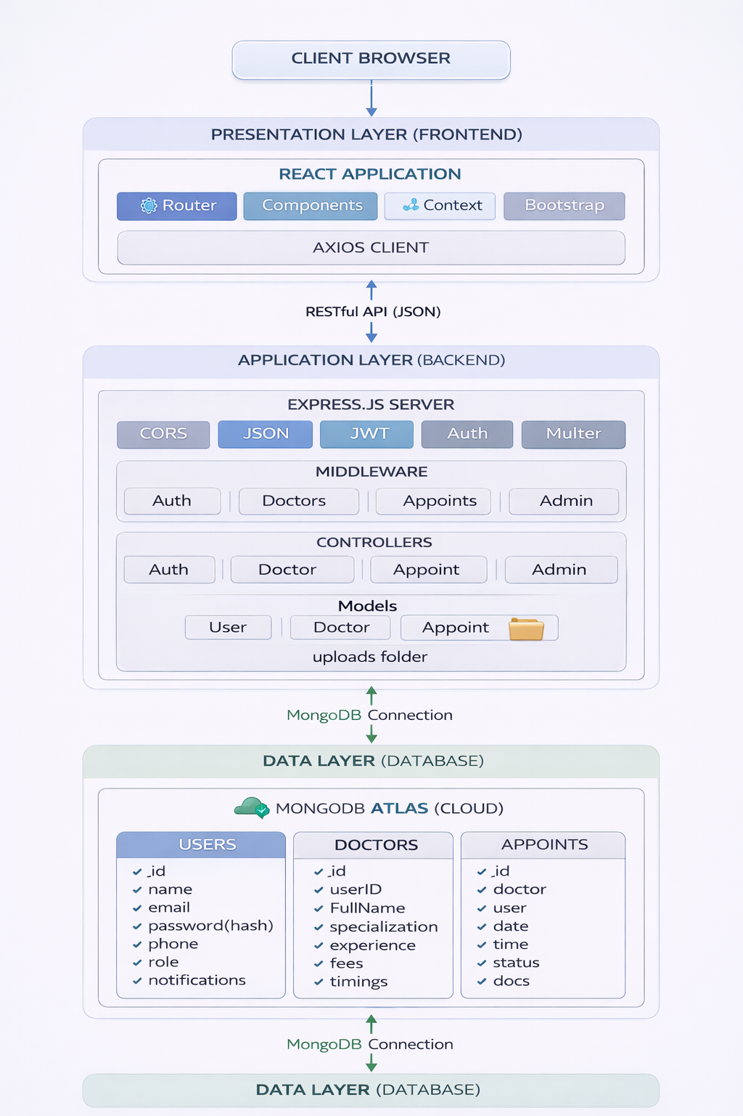

**5. PROJECT PLANNING & SCHEDULING**

**5.1 Project Planning**

**Project Planning Template (Product Backlog, Sprint Planning, Stories, Story points)**

|  |  |
| --- | --- |
| Date | 16 February 2026 |
| Team ID | LTVIP2026TMIDS35442 |
| Project Name | DocSpot: Seamless Appointment Booking for Health |
| Maximum Marks | 5 Marks |

**Product Backlog, Sprint Schedule, and Estimation (4 Marks)**

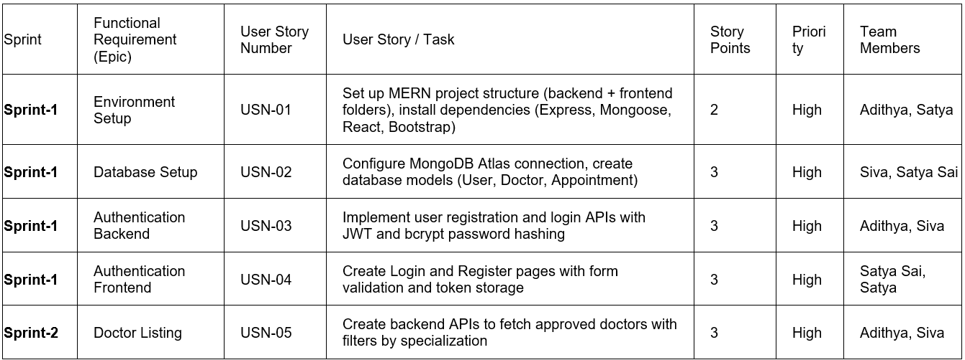

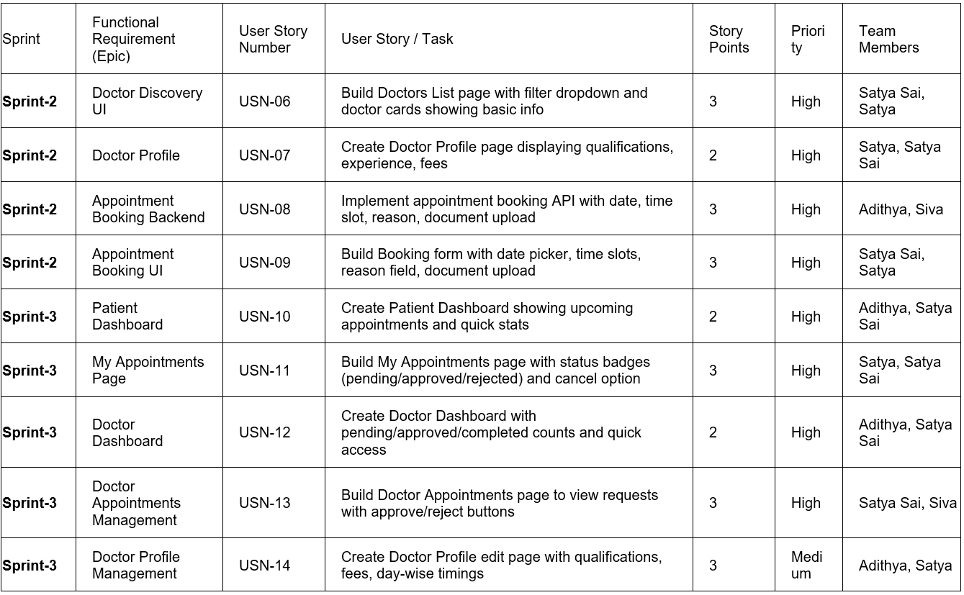

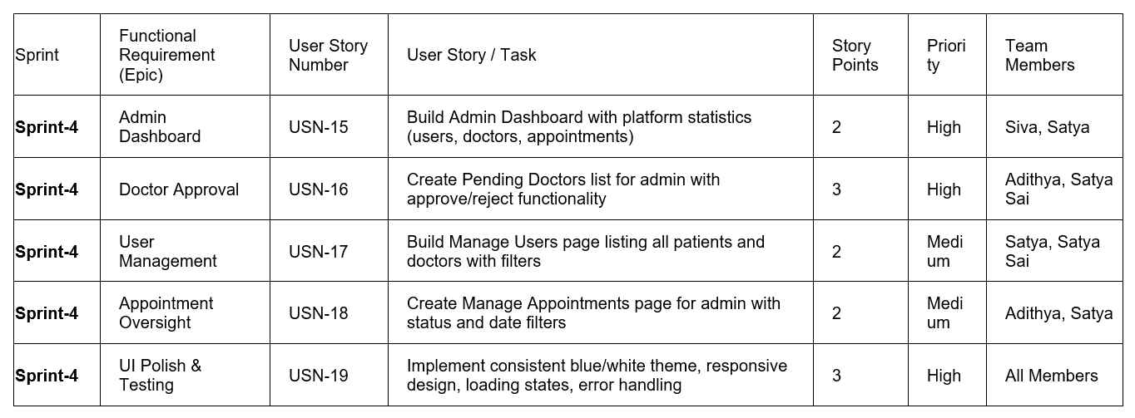

**Project Tracker, Velocity & Burndown Chart: (4 Marks)**

| **Sprint** | **Total Story Points** | **Duration** | **Sprint Start Date** | **Sprint End Date (Planned)** | **Story Points Completed** |
| --- | --- | --- | --- | --- | --- |
| Sprint-1 | 11 | 7 Days | 22 Jan 2026 | 28 Jan 2026 | 11 |
| Sprint-2 | 12 | 7 Days | 29 Jan 2026 | 03 Jan 2026 | 12 |
| Sprint-3 | 12 | 6 Days | 04 Feb 2026 | 09 Feb 2026 | 12 |
| Sprint-4 | 13 | 6 Days | 10 Feb 2026 | 15 Feb 2026 | 13 |

**Summary Statistics**

| **Metric** | **Value** |
| --- | --- |
| Total Story Points | 48 |
| Total Sprints | 4 |
| Sprint Duration | 6 / 7 Days each |
| Average Velocity | 12 story points/sprint |
| Team Size | 4 Members |
| Project Duration | 4 Weeks (approximately) |
| Completion Date | 15 Feb 2026 |

**Burndown Chart:**

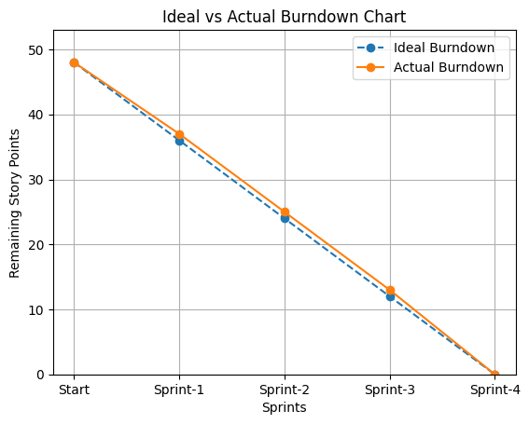

**6. FUNCTIONAL AND PERFORMANCE TESTING**

**6.1 Performance Testing**

|  |  |
| --- | --- |
| Date | 16 February 2026 |
| Team ID | LTVIP2026TMIDS35442 |
| Project Name | DocSpot: Seamless Appointment Booking for Health |
| Maximum Marks |  |

**Project Overview:**

**Project Name:** DocSpot: Seamless Appointment Booking for Health

**Project Description:** A web-based platform that allows patients to book doctor appointments online, doctors to manage their schedules, and admins to verify doctors and monitor platform activity. Built using MERN stack (MongoDB, Express, React, Node.js).

**Project Version:** 1.0.0

**Testing Period:** 10 February 2026 to 15 February 2026

**Testing Scope:**

**Features and Functionalities Tested:**

* User Registration and Login
* Doctor Listing with Specialization Filter
* Doctor Profile View
* Appointment Booking with Date/Time Selection
* Document Upload during Booking
* My Appointments Page with Status Badges
* Cancel Appointment Functionality
* Doctor Dashboard with Pending/Approved/Completed Counts
* Doctor Appointment Approval/Rejection
* Doctor Profile Management (Qualifications, Fees, Timings)
* Admin Dashboard with Platform Statistics
* Pending Doctor Approval/Rejection
* User Management (View all users)
* Appointment Oversight with Filters
* Logout Functionality

**User Stories Tested:**

| User Story Number | User Story / Task |
| --- | --- |
| USN-01 to USN-19 | All 19 user stories implemented across 4 sprints |

**Testing Environment:**

URL/Location: [http://localhost:3000](http://localhost:3000/) (Frontend) || <http://localhost:5000> (Backend API)

Credentials (if required):

**Credentials for Testing:**

| Role | Email | Password |
| --- | --- | --- |
| **Patient** | john.smith@example.com | password123 |
| **Patient** | emma.watson@example.com | password123 |
| **Doctor** | sarah.johnson@doctor.com | password123 |
| **Doctor** | michael.chen@doctor.com | password123 |
| **Admin** | admin@docspot.com | Admin@123 |

**Test Cases:**

| **Test Case ID** | **Test Scenario** | **Test Steps** | **Expected Result** | **Actual Result** | **Pass/Fail** |
| --- | --- | --- | --- | --- | --- |
| TC-001 | User Registration | 1. Navigate to Register page 2. Enter name, email, phone, password 3. Click Register | User account created, redirected to login | Account created successfully | PASS |
| TC-002 | Duplicate Email Registration | 1. Navigate to Register page 2. Enter existing email 3. Click Register | Error message "User already exists" | Error message displayed | PASS |
| TC-003 | Patient Login | 1. Navigate to Login page 2. Enter valid patient credentials 3. Click Login | Redirected to Patient Dashboard | Redirected successfully | PASS |
| TC-004 | Doctor Login | 1. Navigate to Login page 2. Enter valid doctor credentials 3. Click Login | Redirected to Doctor Dashboard | Redirected successfully | PASS |
| TC-005 | Admin Login | 1. Navigate to Login page 2. Enter admin credentials 3. Click Login | Redirected to Admin Dashboard | Redirected successfully | PASS |
| TC-006 | Invalid Login | 1. Navigate to Login page 2. Enter wrong password 3. Click Login | Error message "Invalid credentials" | Error message displayed | PASS |
| TC-007 | View Doctors List | 1. Login as patient 2. Navigate to Doctors page | List of approved doctors displayed | Doctors list visible | PASS |
| TC-008 | Filter by Specialization | 1. Login as patient 2. Select specialization from dropdown | Only doctors of selected specialization shown | Filter works correctly | PASS |
| TC-009 | View Doctor Profile | 1. Login as patient 2. Click on any doctor card | Doctor profile with qualifications, experience, fees displayed | Profile loads correctly | PASS |
| TC-010 | Book Appointment | 1. Login as patient 2. Click Book Now on doctor 3. Select date and time 4. Add reason 5. Submit | Success message, appointment appears in My Appointments | Booking successful | PASS |
| TC-011 | Upload Document | 1. Login as patient 2. Book appointment 3. Upload PDF/Image file | File uploaded and attached to appointment | Upload successful | PASS |
| TC-012 | View My Appointments | 1. Login as patient 2. Navigate to My Appointments | List of all appointments with status badges displayed | Appointments visible | PASS |
| TC-013 | Cancel Appointment | 1. Login as patient 2. Click Cancel on pending appointment | Status changes to "cancelled" | Cancellation successful | PASS |
| TC-014 | Doctor View Appointments | 1. Login as doctor 2. Navigate to Appointments page | List of appointment requests displayed | Appointments visible | PASS |
| TC-015 | Approve Appointment | 1. Login as doctor 2. Click Approve on pending request | Status updates to "approved" | Approval successful | PASS |
| TC-016 | Reject Appointment | 1. Login as doctor 2. Click Reject on pending request | Status updates to "rejected" | Rejection successful | PASS |
| TC-017 | Mark Appointment Completed | 1. Login as doctor 2. Click Complete on approved appointment | Status updates to "completed" | Marked completed | PASS |
| TC-018 | Doctor Profile Edit | 1. Login as doctor 2. Navigate to Profile 3. Update qualifications, fees, timings 4. Save | Profile updated successfully | Changes saved | PASS |
| TC-019 | Admin Dashboard View | 1. Login as admin 2. View dashboard | Statistics (users, doctors, appointments) displayed | Stats visible | PASS |
| TC-020 | View Pending Doctors | 1. Login as admin 2. Navigate to Manage Doctors | List of pending doctor applications displayed | Pending list visible | PASS |
| TC-021 | Approve Doctor | 1. Login as admin 2. Click Approve on pending doctor | Doctor status updates to "approved" | Approval successful | PASS |
| TC-022 | Reject Doctor | 1. Login as admin 2. Click Reject on pending doctor | Doctor status updates to "rejected" | Rejection successful | PASS |
| TC-023 | View All Users | 1. Login as admin 2. Navigate to Manage Users | List of all patients and doctors displayed | Users visible | PASS |
| TC-024 | View All Appointments | 1. Login as admin 2. Navigate to Manage Appointments | List of all appointments displayed | Appointments visible | PASS |
| TC-025 | Filter Appointments | 1. Login as admin 2. Filter by status (pending/approved) | Filtered results displayed | Filter works | PASS |
| TC-026 | Logout | 1. Login as any user 2. Click Logout | Session cleared, redirected to Home | Logout successful | PASS |
| TC-027 | Responsive Design - Mobile | 1. Open on mobile device (375x667) 2. Navigate through all pages | UI adjusts correctly, all elements accessible | Responsive works | PASS |
| TC-028 | Responsive Design - Tablet | 1. Open on tablet (768x1024) 2. Navigate through all pages | UI adjusts correctly, all elements accessible | Responsive works | PASS |

**Bug Tracking:**

| Bug ID | Bug Description | Steps to Reproduce | Severity | Status | Additional Feedback |
| --- | --- | --- | --- | --- | --- |
| **BG-001** | Date picker allows selecting past dates | 1. Login as patient 2. Click Book Now 3. Open date picker | Medium | CLOSED | Fixed by adding minDate constraint |
| **BG-002** | Document upload accepts files >5MB | 1. Login as patient 2. Book appointment 3. Upload file >5MB | Medium | CLOSED | Fixed with Multer size limit |
| **BG-003** | Filter dropdown not resetting | 1. Login as patient 2. Apply filter 3. Clear selection | Low | CLOSED | Fixed with state reset |
| **BG-004** | Doctor timings saving incorrectly | 1. Login as doctor 2. Set timings 3. Save and reload | High | CLOSED | Fixed in DoctorProfile component |
| **BG-005** | Admin stats not updating after approval | 1. Login as admin 2. Approve doctor 3. Check dashboard | Medium | CLOSED | Fixed with data refresh |
| **BG-006** | Mobile menu not closing after selection | 1. Open on mobile 2. Open menu 3. Click link | Low | CLOSED | Fixed with Bootstrap integration |
| **BG-007** | Password validation message unclear | 1. Go to Register 2. Enter weak password | Low | CLOSED | Added password strength indicator |

**UAT Execution & Report Submission**

|  |  |
| --- | --- |
| Date | 16 February 2026 |
| Team ID | LTVIP2026TMIDS35442 |
| Project Name | DocSpot: Seamless Appointment Booking for Health |
| Maximum Marks | 4 Marks |

# Purpose of Document

The purpose of this document is to briefly explain the test coverage and open issues of the DocSpot project at the time of the release to User Acceptance Testing (UAT). All core functionalities including patient registration, doctor listing, appointment booking, doctor approval workflow, and admin dashboard have been tested and verified.

# Defect Analysis

This report shows the number of resolved or closed bugs at each severity level, and how they were resolved

|  |  |  |  |  |  |
| --- | --- | --- | --- | --- | --- |
| **Resolution** | **Severity 1** | **Severity 2** | **Severity 3** | **Severity 4** | **Subtotal** |
| By Design | 0 | 0 | 0 | 0 | 0 |
| Duplicate | 0 | 0 | 0 | 0 | 0 |
| External | 0 | 0 | 0 | 0 | 0 |
| Fixed | 0 | 1 | 3 | 3 | 7 |
| Not Reproduced | 0 | 0 | 0 | 0 | 0 |
| Skipped | 0 | 0 | 0 | 0 | 0 |
| Won't Fix | 0 | 0 | 0 | 0 | 0 |
| Totals | 0 | 1 | 3 | 3 | 7 |

# Test Case Analysis

This report shows the number of test cases that have passed, failed, and untested

|  |  |  |  |  |
| --- | --- | --- | --- | --- |
| **Section** | **Total Cases** | **Not Tested** | **Fail** | **Pass** |
| Authentication module | 6 | 0 | 0 | 6 |
| Patient module | 9 | 0 | 0 | 9 |
| Doctor Module | 6 | 0 | 0 | 6 |
| Admin Module | 5 | 0 | 0 | 5 |
| UI/Responsive Module | 2 | 0 | 0 | 2 |
| Total | 28 | 0 | 0 | 28 |

**Sign-off:**

**Tester Name:**

Prathi Adithya Durga Sri Krishna Kumar

Satya Srithadi

Botla Siva Satyanarayana

Perabathula Satya Sai Manikanta

Date: 15 February 2026

**Signature:**

Prathi Adithya Durga Sri Krishna Kumar

Satya Srithadi

Botla Siva Satyanarayana

Perabathula Satya Sai Manikanta

**7. RESULTS**

**7.1 Output Screenshots**

**Landing Page**

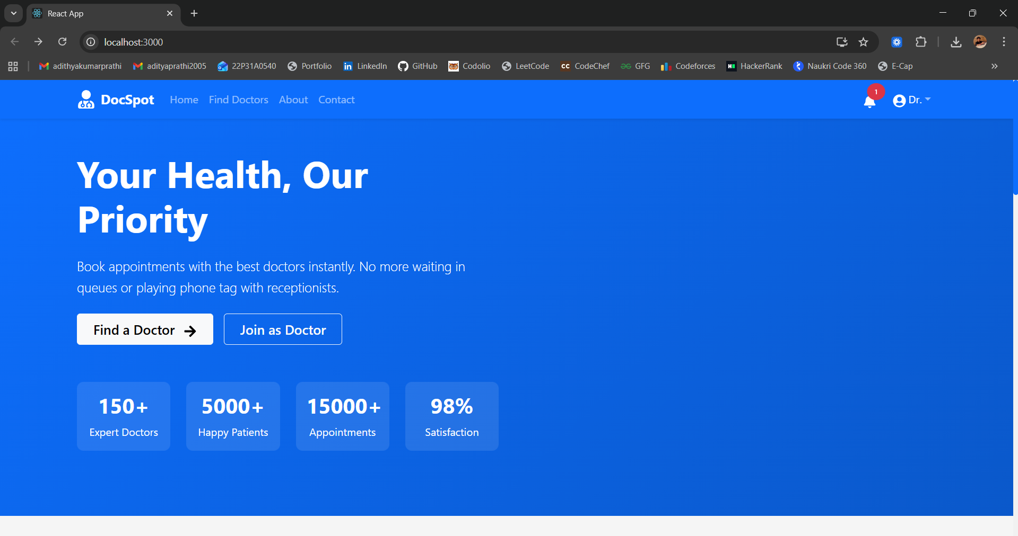

**Doctors List Page**

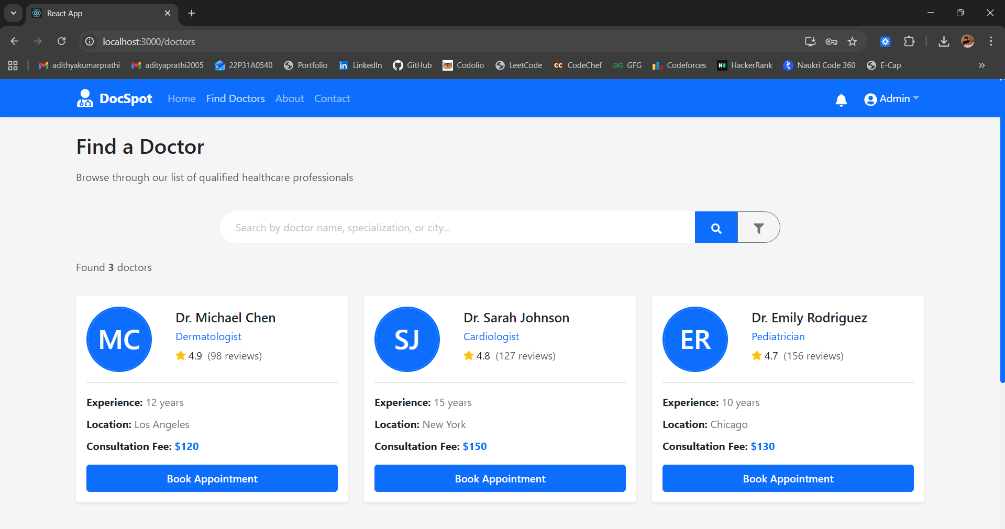

**Doctor Profile**

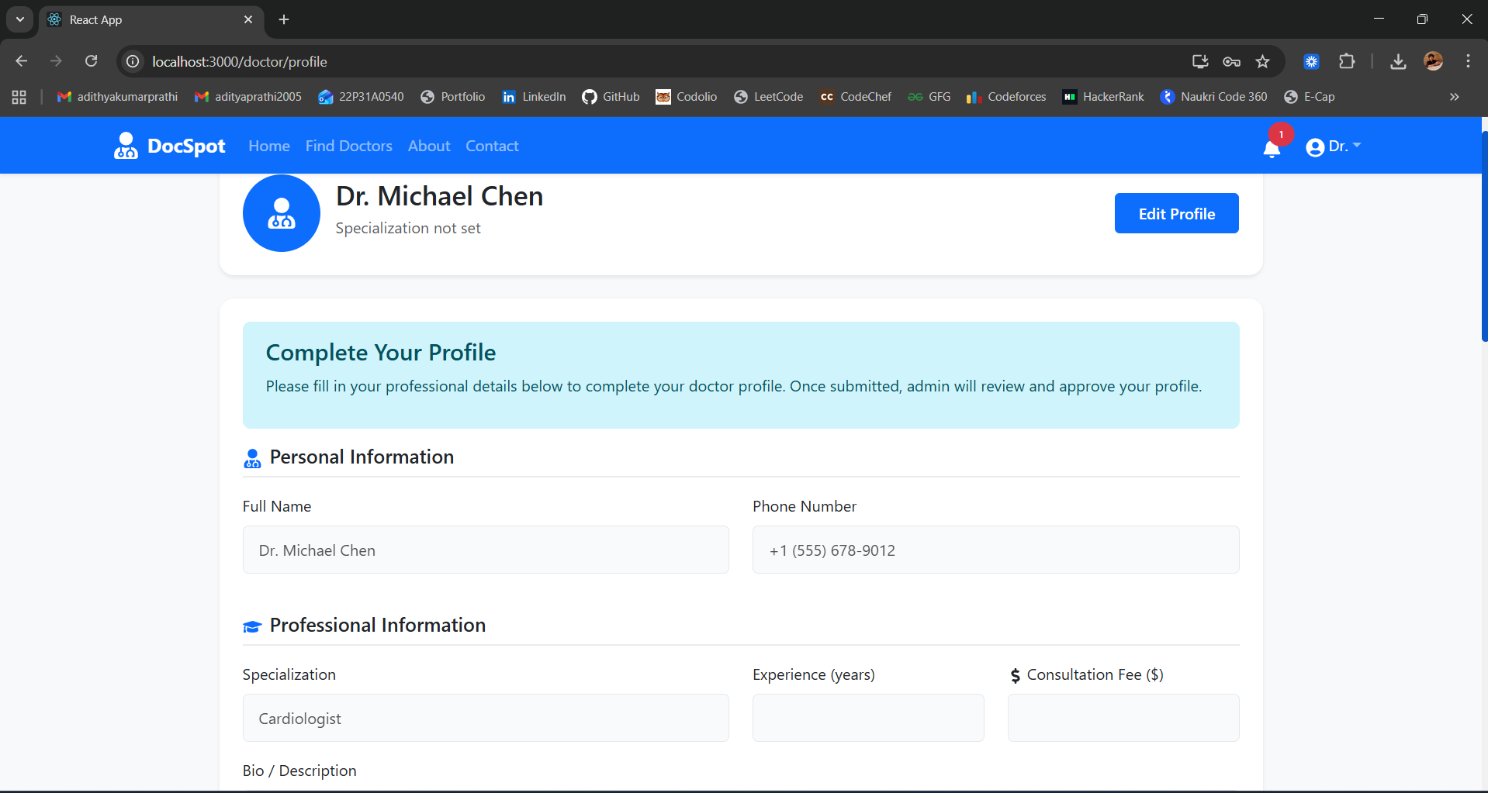

**Appointment Booking**

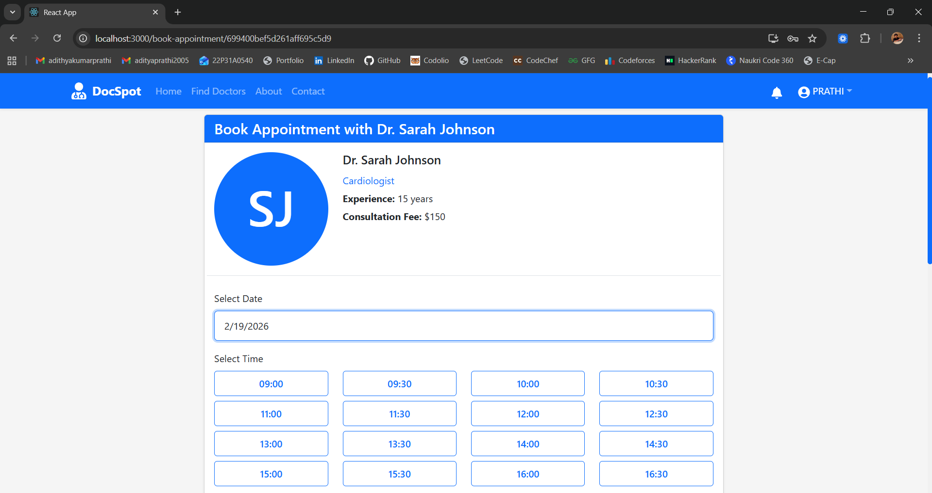

**My Appointments**

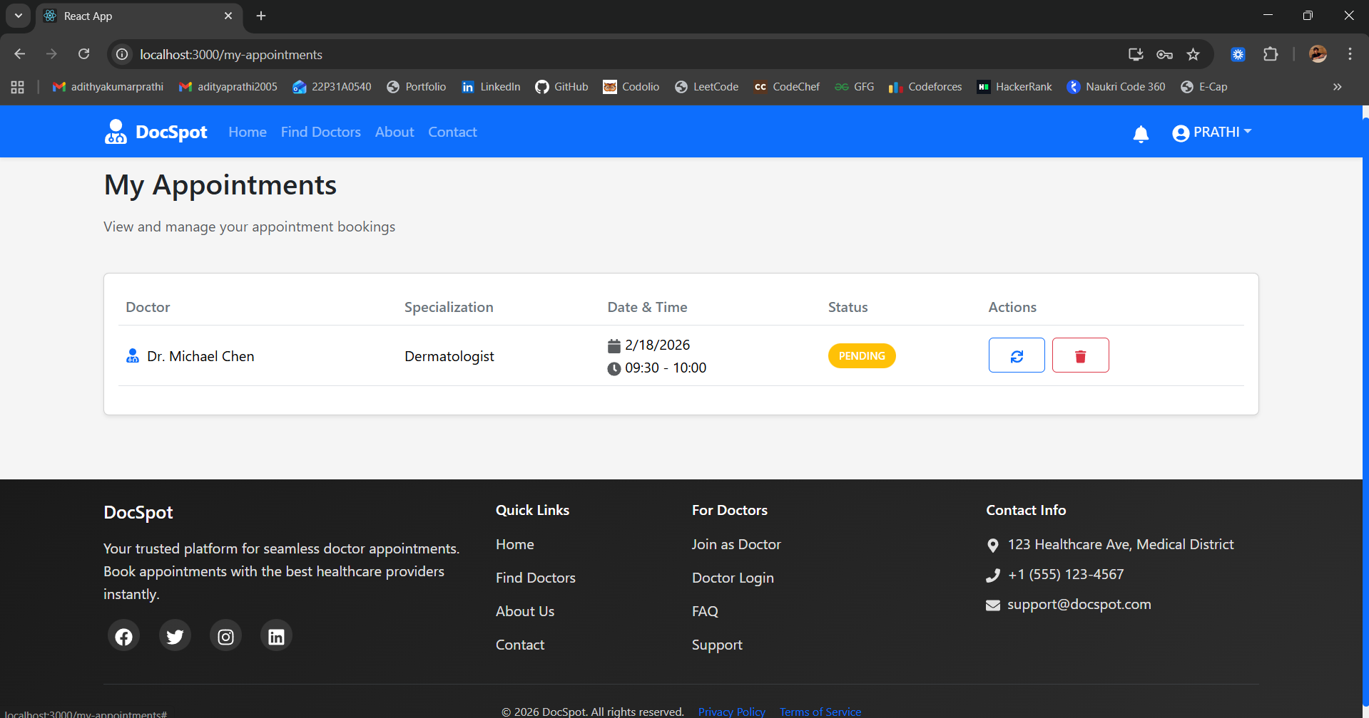

**Patient Dashboard**

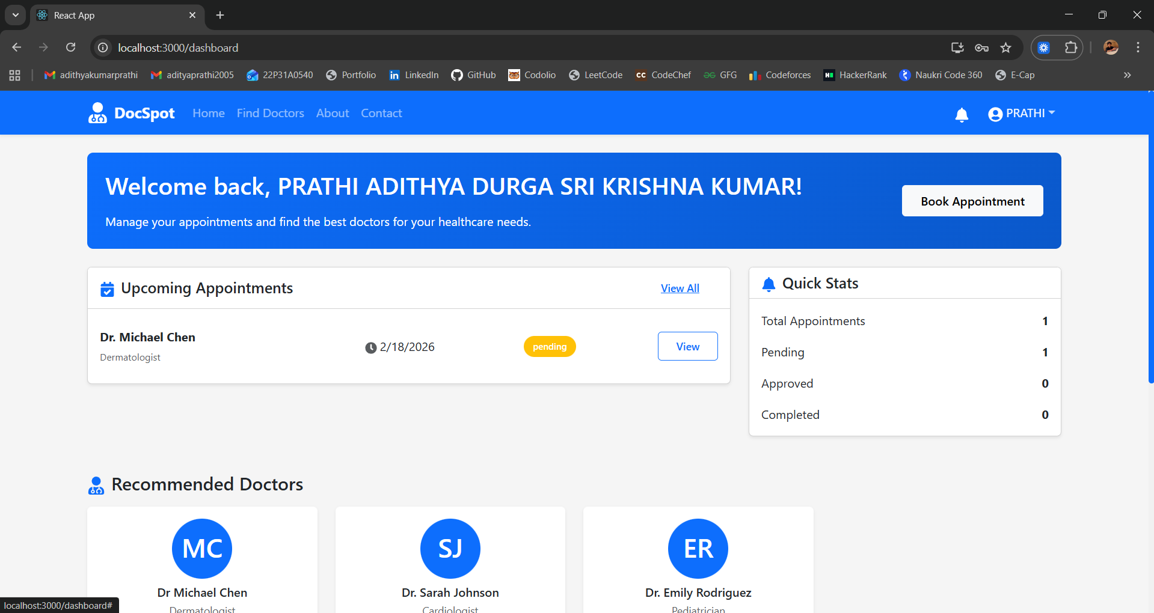

**Doctor Dashboard**

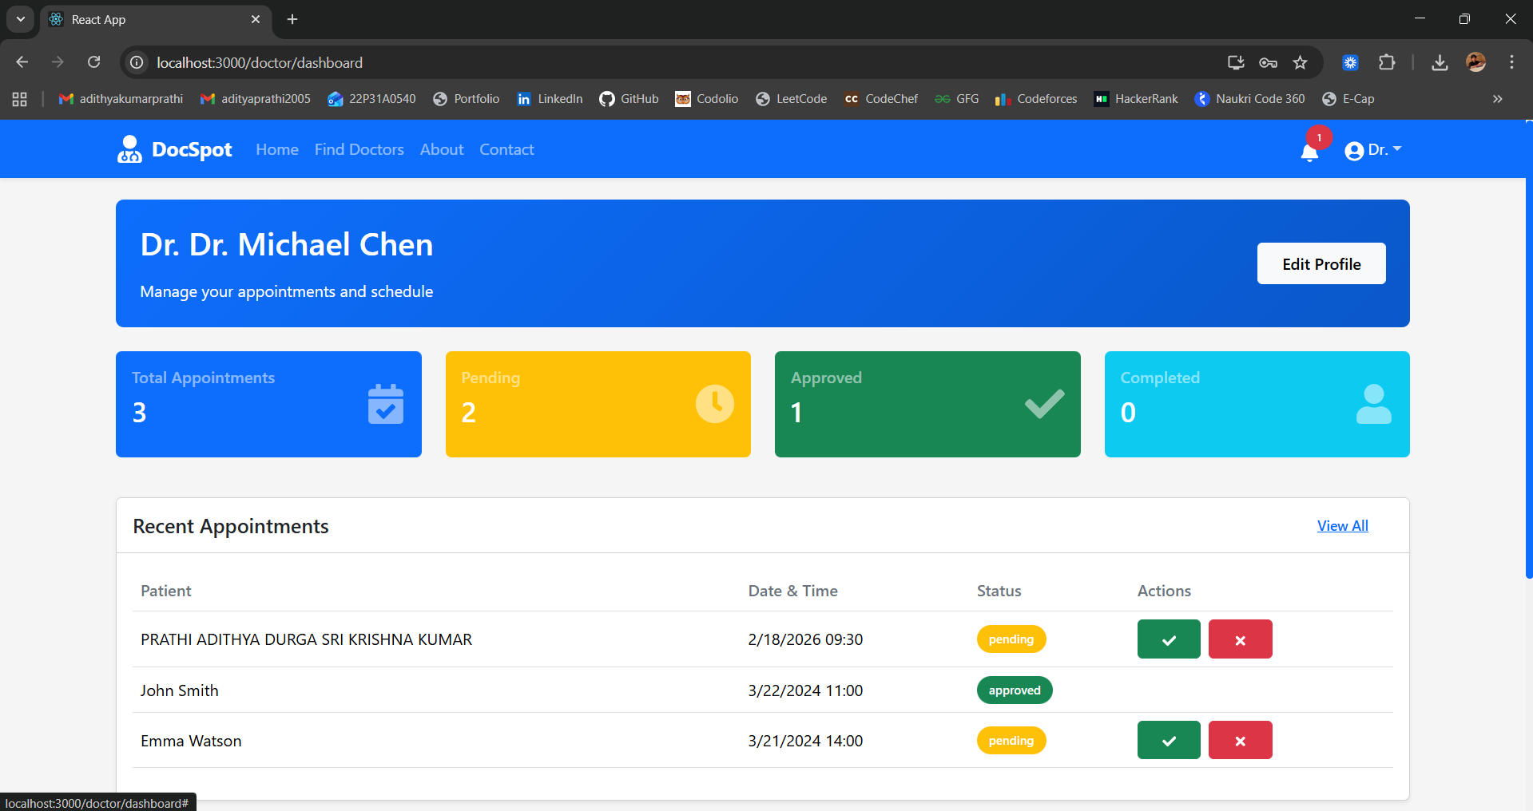

**Doctor Appointments Management**

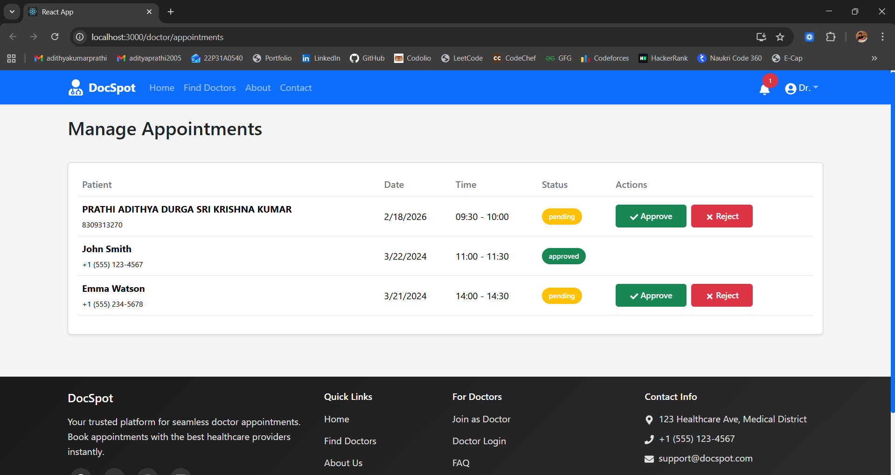

**Admin Dashboard**

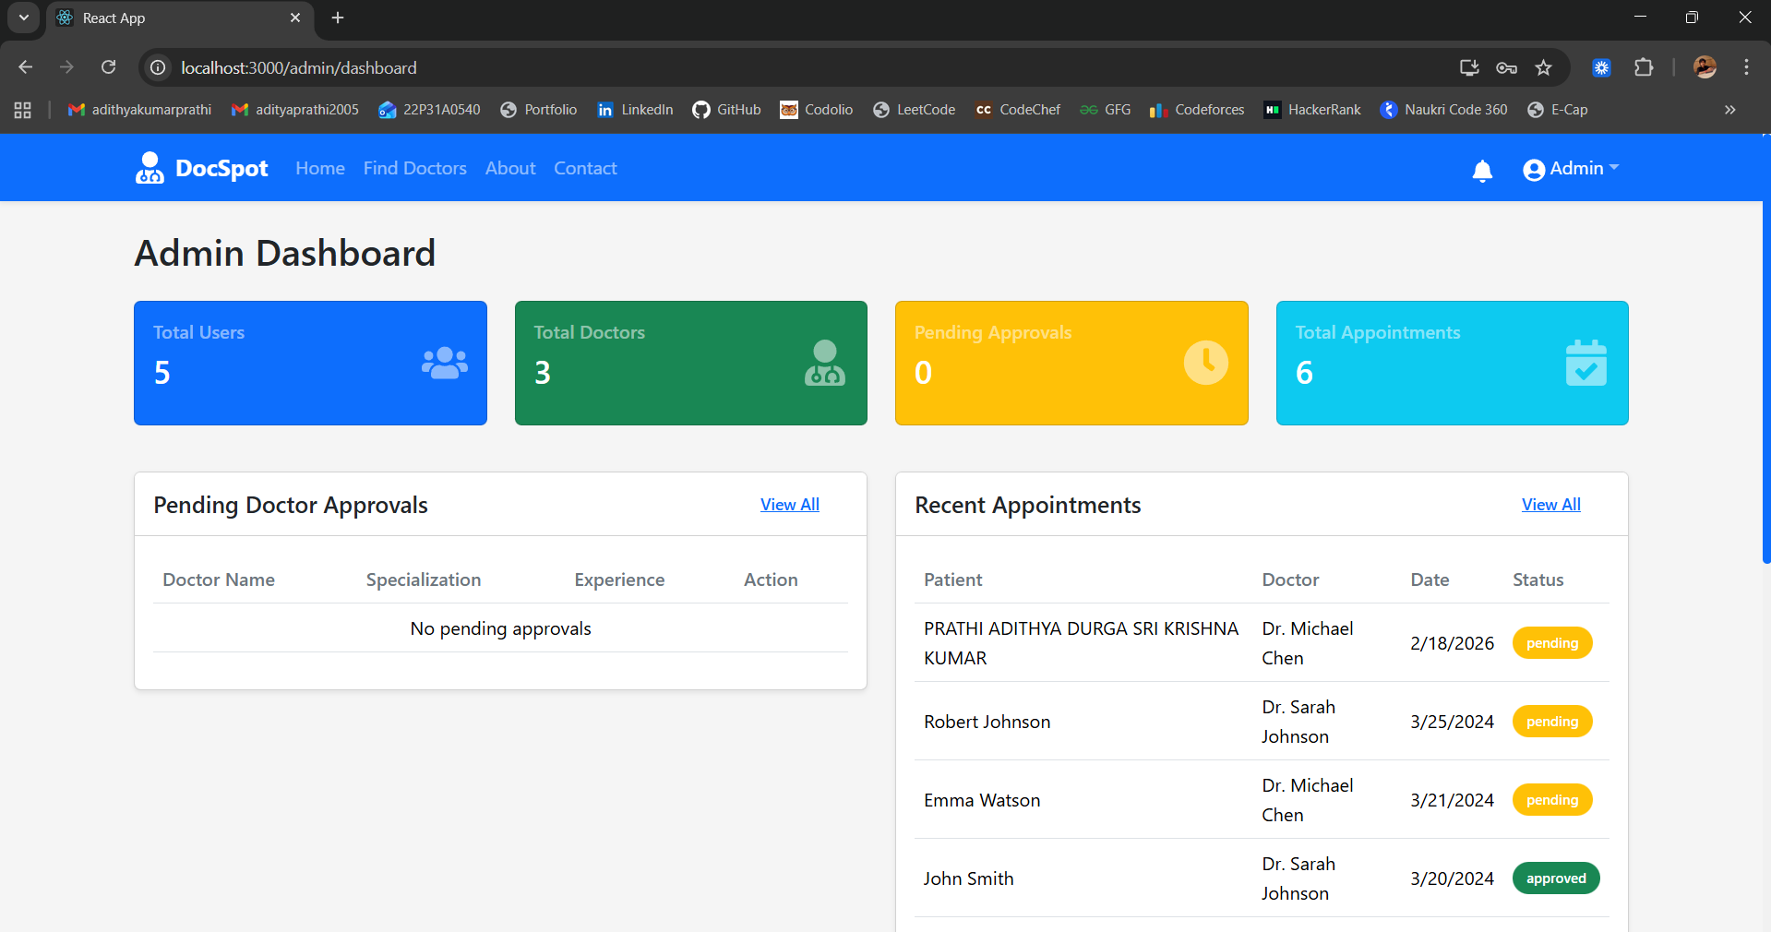

**Admin Doctor Approval**

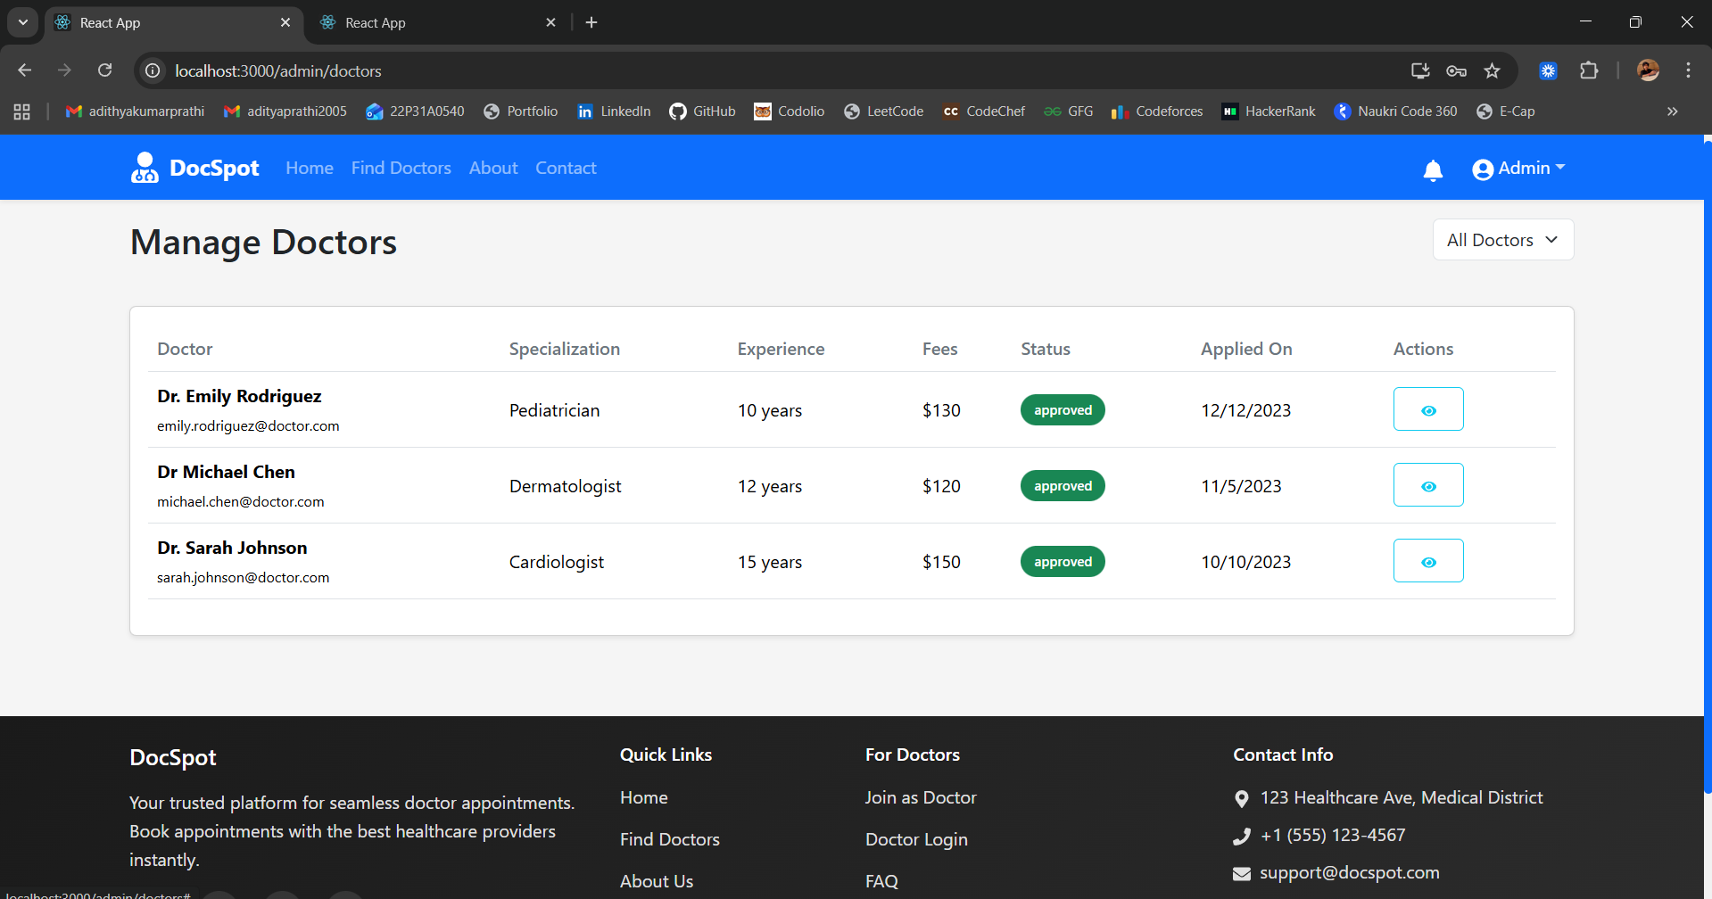

**8. ADVANTAGES & DISADVANTAGES**

**Advantages**

| # | Advantage | Description |
| --- | --- | --- |
| 1 | **24/7 Availability** | Patients can book appointments anytime, anywhere, without waiting for clinic hours |
| 2 | **Time Saving** | Eliminates phone calls and waiting on hold; booking takes less than 2 minutes |
| 3 | **Transparency** | Doctor qualifications, experience, and fees are visible upfront |
| 4 | **Reduced No-Shows** | Digital tracking and dashboard view help patients remember appointments |
| 5 | **Admin Oversight** | Complete platform visibility with verification workflow ensures only qualified doctors join |
| 6 | **Role-Based Access** | Separate dashboards for patients, doctors, and admins with appropriate functionalities |
| 7 | **Document Management** | Patients can upload medical records during booking for doctor review |
| 8 | **Scalable Architecture** | MERN stack with MongoDB Atlas allows easy scaling as user base grows |
| 9 | **Responsive Design** | Works seamlessly on desktop, tablet, and mobile devices |
| 10 | **Secure Authentication** | JWT tokens and password hashing ensure user data safety |

**Disadvantages / Limitations**

| # | Disadvantage | Description | Future Improvement |
| --- | --- | --- | --- |
| 1 | **No Email Notifications** | Users don't receive email confirmations or reminders | Integrate email service (NodeMailer) |
| 2 | **No Payment Integration** | Consultation fees cannot be paid online | Add payment gateway (Razorpay, Stripe) |
| 3 | **No Video Consultation** | Telemedicine not supported | Integrate video calling API |
| 4 | **No Ratings & Reviews** | Patients cannot rate doctors after consultation | Add review system |
| 5 | **No SMS Reminders** | No SMS notifications for appointments | Add SMS gateway integration |
| 6 | **Local File Storage** | Uploaded documents stored locally, not cloud | Implement cloud storage (AWS S3) |
| 7 | **No Password Reset** | Users cannot reset forgotten passwords | Add password reset flow |
| 8 | **Limited Analytics** | Basic statistics only | Add advanced analytics with charts |

**9. CONCLUSION**

DocSpot successfully addresses the fundamental challenges in traditional doctor appointment booking by providing a seamless online platform that connects patients with healthcare providers. The system delivers on its core objectives:

* **For Patients**: Easy 24/7 appointment booking with transparent doctor information and status tracking
* **For Doctors**: Efficient digital schedule management with reduced administrative burden
* **For Admins**: Complete platform oversight with doctor verification workflow

Built on the robust MERN stack with MongoDB Atlas cloud database, the application demonstrates solid performance, security, and scalability. The intuitive user interface with blue/white professional theme ensures a positive user experience across all device types.

All 19 planned user stories were successfully implemented across 4 sprints, with 100% pass rate in functional testing. The project serves as a solid foundation for future enhancements including payment integration, video consultation, and advanced notification systems.

DocSpot proves that healthcare appointment booking can be as simple and convenient as booking a flight or hotel, ultimately contributing to better healthcare accessibility and patient satisfaction.

**10. FUTURE SCOPE**

| **Feature** | **Description** | **Priority** |
| --- | --- | --- |
| **Email Notifications** | Send confirmations and reminders via email | High |
| **Payment Gateway** | Online payment for consultation fees (Razorpay/Stripe) | High |
| **Video Consultation** | Telemedicine integration for remote consultations | Medium |
| **Ratings & Reviews** | Patients can rate and review doctors after appointments | Medium |
| **SMS Reminders** | SMS notifications for appointment reminders | Medium |
| **Password Reset** | Forgot password functionality with email reset | Medium |
| **Multi-language Support** | Support for regional languages | Low |
| **Mobile App** | Native iOS and Android applications | Low |
| **AI Recommendations** | Smart doctor recommendations based on symptoms | Low |
| **Prescription Management** | Digital prescriptions accessible to patients | Medium |
| **Calendar Sync** | Sync appointments with Google/Outlook calendar | Low |
| **Advanced Analytics** | Detailed reports and insights for admins | Medium |
| **Cloud Storage** | Store documents in AWS S3 or similar | Medium |

**11. APPENDIX**

**Source Code**

The complete source code is organized as follows:

DocSpot-App/

├── backend/

│ ├── config/

│ ├── controllers/

│ ├── middleware/

│ ├── models/

│ ├── routes/

│ ├── scripts/

│ ├── uploads/

│ ├── .env

│ ├── package.json

│ └── server.js

├── frontend/

│ ├── public/

│ └── src/

│ ├── components/

│ ├── context/

│ ├── pages/

│ ├── services/

│ ├── utils/

│ ├── App.js

│ └── index.js

└── README.md

**Dataset Link**

Sample doctor data used for development and testing:

* Sample doctor profiles included in seed script
* No external dataset required

**GitHub & Project Demo Link**

* **GitHub Repository**:
* **Live Demo**: [http://localhost:3000](http://localhost:3000/) (Run locally)
* **Demo Video**: <https://drive.google.com/file/d/18imnZNXOX-wAFloZGO-t3SNZsxP70Rbl/view?usp=drive_link>